1. Introduction
1.1 Purpose
This Software Requirements Specification (SRS) document describes the high-level functional and structural requirements of the Whizard Talent-Building Ecosystem.
Enterprises today face a structural talent problem: they cannot reliably convert learning spend into workforce readiness or hiring confidence. Traditional universities, generic courses, static LMS platforms, and interview-driven hiring all fail to produce predictable, job-ready talent.
Whizard is conceived as a AI-native workforce readiness platform that replaces traditional corporate L&D, reduces hiring risk, and builds a continuous talent pipeline from colleges to enterprises using a Workforce Readiness Capability Framework (WRCF). Unlike traditional courses, Whizard uses multi-agent AI and work-object simulations to enable realistic exposure besides generating verifiable evidence of mastery.

Whizard is a multi-application digital platform designed to build structured, measurable workforce readiness within colleges through long-term, project-first mastery clubs. The system integrates students, colleges, industry clubs, and companies into a unified capability-driven ecosystem.
This document defines the scope, actors, system boundaries, operating guardrails, and high-level interdependencies between the applications that constitute Whizard.
This SRS serves as the reference document for:
- Product Owners
- System Architects
- Development Teams
- UI/UX Designers
- Testing Teams
- Implementation and Deployment Teams
1.2 Scope
Whizard is a structured, role-based ecosystem that operationalizes student development across four progressive stages:
- Exploration
- Skill Foundation
- Mastery
- Industry Integration
The system consists of four integrated but role-segregated applications:
- Club Admin App
- Student App
- College App
- Company App
The core objective of Whizard is to:
- Build early performance signals for students before graduation
- Standardize industry-aligned capability frameworks
- Enable structured skill progression tracking
- Facilitate internship and employment pipelines
- Reduce hiring friction and onboarding time
- Create a sustainable campus talent pipeline
Whizard operates on a Work-Object-Centric Workforce Readiness Capability Framework (WRCF) structured as:
Sector
Industry
→ Functional Group
→ Primary Work Object (PWO)
→ Secondary Work Object (SWO)
→ Capability
→ Proficiency
→ Skill
→ Task
→ Control Point
→ Evidence
→ Evaluator
As per WRCF
- Capability Instances belong to the Industry.
- Competence belongs to the Role.
- People are assessed against Role Competence.
- Role competence is achieved through verified Capability Instances.
- A Capability Instance = SWO + Capability + Proficiency.
WRCF standardizes:
- Industry definitions
- Role definitions
- Functional groups
- Capability structures
- Skill evidences
- Certification pathways
Whizard is not a job portal. It is a capability-governed talent incubation and industry-integration platform.
1.3 Definitions, Acronyms, and Abbreviations
Whizard – A structured college-based talent development ecosystem.
Parent Club – An industry-domain-level governance entity (e.g., Manufacturing, Finance, AI).
Club – A structured learning and mastery unit under a Parent Club. Typically, not necessarily, operates at the Industry Function group.
Certification Level – Progressive levels within a club reflecting increasing competence and mastery.
Exploration Stage – Stage where students can explore up to three clubs.
Mastery Stage – Stage where students focus on one primary club and complete advanced certifications and projects.
Industry Integration Stage – Stage where students engage with companies through internships, projects, and conditional training programs.
Workforce Readiness Capability Framework — A structured model defining roles, capabilities, skills, control points, and evidence aligned to industry standards.

0. Sector:
Definition:
A broad economic grouping of industries; provides macro-level context; not an organization or curriculum.
Purpose in WRCF:
Provides aggregate context to similar group of industry in the capability models.
Examples:
Energy & Utilities, Discreet Manufacturing, IT Services etc

1️⃣ Industry
Definition:
A broad economic domain in which organizations operate, defined by a common production logic, regulatory structure, and value chain.
Purpose in WRCF:
Provides the contextual ecosystem within which capability models are built.
Examples:
Thermal Power Generation
Retail Banking
IT Software Development
Key Principle:
Industry defines what kind of work exists, not who performs it.
2️⃣ Company
Definition:
A specific legal entity operating within an industry that has its own asset base, processes, standards, and operating philosophy.
Purpose in WRCF:
Company is where industry framework gets customized (SOPs, equipment make, compliance rules).
Key Distinction:
Industry = generic capability model
Company = contextual implementation of that model
Example:
Industry: Thermal Power
Company: NTPC / Tata Power / State GENCO
3️⃣ Functional Group
Definition:
A major operational or support domain within an industry where related systems and processes are grouped.
Purpose in WRCF:
Organizes work into manageable operational clusters.
Examples (Thermal Power):
Coal Handling Plant (CHP)
Boiler
Turbine
Generator
Electrical Systems
C&I
Ash Handling
Key Insight:
Functional Group = where work happens.

4️⃣ Primary Work Object (PWO)
Definition:
A major system, process cluster, or operational domain within a functional group that delivers a distinct operational purpose.
Purpose in WRCF:
Defines the competency boundary for capability modeling.
Examples (CHP):
Coal Receiving System
Conveying Systems
Crushing & Sizing
Stacking & Reclaiming
Dust, Environment & Safety
Key Insight:
PWO = What major system must be mastered.

5️⃣ Secondary Work Object (SWO)
Definition:
A specific physical asset, system, equipment, sub-process or even deliverable within a Primary Work Object.
Purpose in WRCF:
Enables granular capability and task definition.
Examples (Crushing & Sizing PWO):
Coal Crusher
Crusher Drive System
Crusher Rotor
Vibrating Screen
Screen Drive
Key Insight:
SWO = Where tasks are actually performed.
6️⃣ Capabilities
Definition:
Universal but fully Observable, role-agnostic abilities required to effectively interact with a work object.
Capabilities describe how a person engages with a system, not the equipment they perform over.
Code | Capability
CAP-01 | Work Object Familiarization
CAP-02 | Process Familiarization (Input → Output)
CAP-03 | Operation Execution
CAP-04 | Monitoring & Exception Detection
CAP-05 | Fault / Error Recognition
CAP-06 | First Response & Resolution
CAP-07 | Preventive / Proactive Action
CAP-08 | Optimization & Judgment
CAP-09 | Compliance & Safety Awareness
CAP-10 | Documentation, Communication & Handover
Key Insight:
Capability = Qualitative Type of engagement with physical asset, subprocess or system.
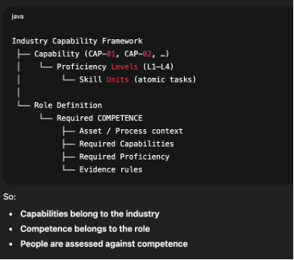
Capability vs Competence
Capability is a reusable human action ability that can be trained and developed independent of role or context while
Competence is the verified ability to apply one or more capabilities effectively, safely, and consistently in a specific role, asset, and process context.

Proficiency
Definition
The degree of autonomy, judgment, and responsibility with which a capability is exercised.
Proficiency Level | Label | Description | Risk Exposure
L1 | System Awareness | Knowledge only | Zero
L2 | Assisted Execution | Perform under observation | Zero
L3A | Conditional Independence – Supervised | Perform alone, supervisor nearby | Low
L3B | Conditional Independence – Scoped | Perform within boundaries | Controlled
L4 | Full Independence | Asset/ Service -level autonomy | Institutionally backed
L1 – Awareness - Validate conceptual understanding before physical execution
System shall assign plant process learning modules linked with respective role in relation to requisite:
Functional Group
Asset / Service
Capability
The system shall conduct knowledge assessment before L2 unlock. Validation of L1 proficiency level to be assessed via various formative and formal assessments.
L2 – Assisted Execution
Demonstrate controlled task execution under supervision. ("Show me you can do it")
During Internship creation, based on the role attached to Internship, User can select predefined Skills and respective tasks while creating Weekly Schedule
Student shall log execution attempt and capture respective evidence against each task. Mentor shall validate performance live or post-task. System shall require X successful supervised attempts before successful completion of task.
Risk:
Supervisor exposure = zero (observational only).
L3A Conditional Independence
Test low-risk autonomy with standby supervision. ("Do it, I’m nearby")
Typically in the initial weeks of Internships Only low-risk tasks are being assigned
Mentor should remain “On Standby” during execution. System shall enforce minimum successful repetition threshold. Safety violation shall auto-reset stage progression.
Risk:
Supervisor risk = low and controlled.
L3B– Conditional Independence (Scoped)
Independence is boundary-constrained. ("You can do this — within boundaries")
System shall define operational boundaries per asset:
Example parameters:
Temperature range
Vibration limit
Misalignment tolerance
Pressure threshold
Student shall log independent task performance. The system shall define escalation triggers. System shall record:
Incident-free execution
Correct escalation events
Time-to-escalation
Decision quality
Risk:
Shared between supervisor and system.
Key rule
Proficiency is how well, not what. It is applied to capabilities. It is used to define trust boundaries
📌 Proficiency answers: “How independently can this action be performed?”
7️⃣ Skill
Definition:
A specific, demonstrable ability that enables a person to perform a defined action under a given capability for a given work object.
Structure:
Skill =
(PWO + SWO + Capability + Proficiency)
Example:
“Start crusher drive motor as per SOP”
“Identify belt misalignment condition”
“Monitor dust extraction airflow trend”

Important Clarification:
Skills are operationally meaningful.
Skills are validated through tasks.
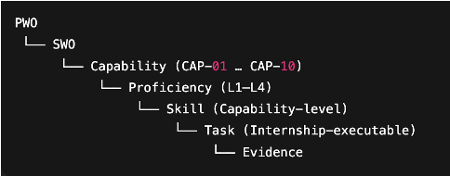
🔎 How Everything Connects (Hierarchy View)
Industry
→ Functional Group
→ Primary Work Object (PWO)
→ Secondary Work Object (SWO) + Capability + Proficiency Level
→ Skill
→ Task
→ Control Point
→ Evidence
→ Evaluator
Task
📌 Definition
A Task is a clearly defined, observable unit of work performed on a specific Secondary Work Object to demonstrate a specific Skill under a defined Capability and Proficiency level.
It is the smallest executable field action that can be:
Assigned during internship
Performed on the shop floor
Observed by a supervisor
Logged in the system
Validated objectively
Structure of a Task
Task = (PWO + SWO + Skill + Context + Mode of Execution)
Example:
“Start crusher drive motor as per SOP and record start-up current”
Control Points
Definition:
Observable validation checkpoints that confirm whether a skill has been correctly demonstrated.
Control Points define:
What must be verified
What evidence is acceptable
Who validates it
Examples:
SOP followed step-by-step
Alarm acknowledged within time limit
Inspection recorded in logbook
Hazard escalated as per protocol
Control Point Structure:
Skill → Task → Control Point → Evidence → Evaluator
Key Insight:
Control Points create trust.
They convert “He knows” into
“He has demonstrated and been validated.”
Tasks build evidence
Evidence validates skills
Validated skills authorize work and builds trust
Evidence
📌 Definition
Evidence is the documented or observable proof that a Task was executed correctly and that the associated Skill has been demonstrated to the required proficiency level.
Evidence converts:
“I did it” into “It is verifiably done.”
📌 Evidence Types in WRCF
Evidence Type | Description | Example
Observation | Direct visual confirmation | Supervisor observed SOP compliance
Log Entry | Entry in official register | Start-up current logged
Checklist | Signed inspection checklist | Drain inspection record
Alarm Log | Control room record | Alarm acknowledged in DCS
Photo / Video | Visual record | PPE compliance photo
Drill Record | Simulation participation | Fire drill sign-off
Trend Review | Analytical validation | Vibration trend analysis
Incident Report | Structured event documentation | Root cause report
Communication Log | Coordinated action | Shift handover note
📌 Evidence Must Be:
Verifiable
Traceable
Linked to specific task
Linked to evaluator
Time-stamped
Immutable (ideally)
DESIGN PRINCIPLES (PIN THESE)
1. Functional Groups define where work happens.
2. Work Objects are the anchors
3. Capabilities are universal
4. Proficiency defines autonomy
5. Skills are atomic actions
6. Control points define trust
7. Courses prepare; internships validate
8. Roles declare trust
1.4 Overall Description
1.4.1 Product Perspective
Whizard is a distributed multi-application ecosystem operating on a unified backend data and capability architecture.
The system consists of:
- Governance Layer (Club Admin App)
- Execution Layer (Student App)
- Institutional Integration Layer (College App)
- Industry Integration Layer (Company App)
All applications are interconnected through shared data structures, user role management, and the Workforce Readiness Capability Framework.
Each application enforces strict role-based access control (RBAC) and operates within clearly defined authority boundaries.
1.4.2 Product Functions (High-Level)
The Whizard ecosystem enables:
- Creation and governance of industry-aligned clubs
- Definition and version control of capability frameworks
- Student onboarding and certification progression tracking
- Social collaboration and communication
- Course and project management
- Internship and job posting management
- Structured evaluation and feedback loops
- Institutional analytics and job readiness indexing
- Corporate training and conditional offer management
- Billing and payment management for corporate services
1.4.3 User Classes and Characteristics
The system includes the following primary user classes:
A. Club Governance Users
- System Admin
- Club Admin
- Club Corporate Manager
- Club Content Manager
- Club Communication Manager
These users define structure, standards, certifications, corporate partnerships, and communication governance.
B. Student Users
- Student
- Local Chapter Club Executive
- College / Club Alumni
Students progress through certification pathways, build project portfolios, and apply for opportunities.
C. College Users
- College Admin
- Placement Cell
- Club Coordinators
These users monitor student development, manage local chapters, and access institutional readiness analytics.
D. Company Users
- HR Head
- Recruitment Manager
- Functional Manager
- Training Manager
- Department Head
- Department Manager
- Company Admin
These users manage internships, job requisitions, training programs, evaluations, and capability customization.
1.5 Operating Environment
Whizard is intended to operate as:
- A cloud-based web and mobile-enabled multi-tenant platform
- Secure, role-based access-controlled environment
- Scalable architecture supporting multiple colleges, clubs, and companies
- Data-isolated but framework-integrated ecosystem
The system must support:
- Multi-institution onboarding
- Multi-company onboarding
- Version-controlled framework customization
- Secure document and transcript uploads
- Role-segregated analytics dashboards
1.6 Design and Implementation Constraints
The system shall adhere to the following constraints:
- Role-Based Access Control (RBAC) must be enforced across all applications.
- Certification advancement must require evidence-based evaluation.
- Industry-wide framework modifications must follow version control protocols.
- Student data visibility must be permission-driven.
- Colleges cannot alter industry-wide capability standards.
- Companies may customize frameworks but cannot modify industry baseline definitions.
- Data privacy and controlled access must be maintained across all actor categories.
1.7 Assumptions and Dependencies
The Whizard system operates under the following assumptions:
- Colleges will actively onboard students and support local chapters.
- Companies will define roles aligned to the capability framework.
- Students will participate in structured progression pathways.
- Clubs will maintain updated certification structures and content pipelines.
System-level dependencies include:
- Active collaboration between Club Governance and Company stakeholders
- Accurate student participation data
- Institutional cooperation for internship evaluations
- Industry engagement in project sponsorships
The effectiveness of Whizard depends on coordinated participation across all four applications.
1.8 Document Organization
This SRS document is structured as follows:
- Section 1: Introduction
- Section 2: Overall Description
- Section 3: Specific Requirements
- Section 4: External Interface Requirements
- Section 5: Non-Functional Requirements
- Section 6: Data Model and Entity Relationships
- Section 7: Security and Compliance Requirements

2. Overall Description
2.1 Product Perspective
Whizard is a cloud-based, multi-tenant, role-driven ecosystem designed to integrate academic institutions, industry governance bodies, and companies into a structured workforce readiness pipeline.
The system is architected as four logically separated but data-integrated applications:
- Club Admin App (Governance Layer)
- Student App (Execution Layer)
- College App (Institutional Integration Layer)
- Company App (Industry Integration Layer)
All four applications operate over a centralized core platform consisting of:
- Identity & Role Management Engine
- Workforce Readiness Capability Framework (WRCF) Engine
- Certification & Progression Engine
- Project & Event Management Engine
- Internship & Job Lifecycle Engine
- Communication & Social Engine
- Billing & Subscription Engine
- Analytics & Reporting Engine
2.1.1 System Boundary
Whizard operates as:
- A centralized SaaS platform
- A shared capability governance model
- A distributed role-based application interface
External entities interacting with Whizard include:
- Colleges (Institutional Administrations)
- Companies (Industry Partners)
- Students
- Service Providers (Content & Training Teams)
The platform does not manage payroll, academic grading systems, or corporate HRMS systems directly, but may integrate with them via APIs where applicable.
2.2 Product Functions
At a high level, Whizard provides the following major functional capabilities:
2.2.1 Governance Functions (Club Admin App)
- Creation and management of Parent Clubs
- Creation and management of Clubs
- Definition and versioning of Workforce Readiness Capability Framework
- Definition of Industry-wide role structures
- Certification level design and progression logic
- Onboarding and management of Companies
- Onboarding and management of Colleges
- Onboarding and management of Content Service Providers
- Communication moderation within club ecosystems
- Corporate pricing, sponsorships, advertising configuration
2.2.2 Student Lifecycle Functions (Student App)
- Student onboarding and profile creation
- Exploration of up to three clubs
- Selection of primary club for certification pathway
- Enrollment in courses and projects
- Participation in events and contests
- Submission of project deliverables
- Capability evidence tracking
- Certification progression monitoring
- Internship and job application submission
- Participation in Whizard Social
- Mentorship interactions
2.2.3 Institutional Functions (College App)
- Student bulk onboarding
- Semester transcript uploads
- Launch and management of local club chapters
- Monitoring of student capability progression
- Job readiness index visibility
- Internship coordination and mid-term feedback interface
- Institutional analytics dashboards
- Communication with students via platform
2.2.4 Industry Functions (Company App)
- Company onboarding and profile management
- Department creation and role mapping
- Customization of Workforce Readiness Capability Framework
- Internship requisition posting
- Job requisition posting
- Project and challenge sponsorship
- Internship evaluation and scoring
- Conditional offer training program management
- Trainee assessment and evaluation
- Recruitment analytics
- Billing and payment management
- Advertisement campaign management
2.2.5 Workforce Readiness Capability Framework Model
The WRCF shall support a work-object-based hierarchy:
- Primary Work Object (PWO) – Major industrial asset or process context.
- Secondary Work Object (SWO) – Sub-component or operational subset.
- Capability – Industry-defined ability.
- Proficiency – Level of mastery (L1–L4).
- Skill – Atomic demonstrable competency.
- Task – Executable work action.
- Control Point – Validation checkpoint.
- Evidence – Proof of task execution.
- Evaluator – Authorized supervisor validating mastery.
The system shall support Role Competence defined as:
Role
→ Assigned Capability Instances
→ Required Skills
→ Required Tasks
→ Required Evidence Rules
A person becomes “Role Ready” only when all required capability instances are verified.
2.3 User Classes and Characteristics
The Whizard system supports multiple user classes with distinct authority scopes.
2.3.1 System-Level Users
System Admin
- Full system configuration control
- Multi-tenant governance authority
- Access to global configuration and system logs
2.3.2 Club-Level Users
Club Admin
- Defines certification architecture
- Manages capability framework
- Controls industry governance structures
Club Corporate Manager
- Manages corporate partnerships
- Oversees sponsorships and pricing packages
Club Content Manager
- Manages courses, projects, training providers
Club Communication Manager
- Moderates social communication ecosystem
2.3.3 Student-Level Users
Student
- Enrolls in clubs and certifications
- Submits projects and assessments
- Applies for internships and jobs
Local Chapter Club Executive
- Limited administrative privileges within college chapter
Alumni
- Limited access for networking and mentoring
2.3.4 College-Level Users
College Admin
- Onboards students
- Manages local club chapters
- Uploads transcripts
Placement Cell
- Views student progression and job readiness data
- Coordinates with companies
Club Coordinators
- Monitor club-specific progress within institution
2.3.5 Company-Level Users
Company Admin
- Manages company page
- Configures departments and users
- Customizes framework mapping
HR Head
- Approval authority for requisitions
Recruitment Manager
- Posts internships and jobs
- Manages recruitment pipeline
Functional Manager
- Evaluates interns
Training Manager
- Manages training programs
Department Head / Department Manager
- Approves and mentors internships
- Conducts evaluations and interviews
2.4 Operating Environment
Whizard shall operate in the following environment:
- Cloud-hosted SaaS infrastructure
- Web-based application interface
- Mobile-responsive interface
- Secure multi-tenant architecture
- API-enabled integration capability
Supported environments:
- Modern web browsers (Chrome, Edge, Safari, Firefox)
- Secure HTTPS-based communication
- Role-based authentication and authorization
2.5 Design and Implementation Constraints
The system shall adhere to the following constraints:
- Role-Based Access Control (RBAC) must be enforced across all modules.
- Certification progression must require evidence validation.
- Capability framework modifications must be version-controlled.
- Multi-tenant data isolation must be maintained.
- Personal data protection regulations must be complied with.
- Company-level customizations must not override industry-level baseline definitions.
- Students cannot modify evaluation outcomes.
- Colleges cannot alter industry-defined role competence definitions.
2.6 User Documentation
The system shall provide:
- Role-specific onboarding guides
- User manuals for each application
- Video walkthroughs
- In-app guided workflows
- Help center documentation
- FAQ and support request mechanism
2.7 Assumptions and Dependencies
2.7.1 Assumptions
- Colleges will support local chapter operations.
- Companies will participate in internships and role mapping.
- Students will engage in structured progression pathways.
- Service providers will maintain updated content pipelines.
2.7.2 Dependencies
The system depends on:
- Active industry participation
- Institutional cooperation for internship evaluation
- Reliable student engagement data
- Periodic framework updates aligned to industry changes
- Secure and scalable cloud infrastructure
2.8 System-Level Guardrails
The Whizard platform operates under the following structural guardrails:
- Governance integrity must be preserved across all modules.
- Capability definitions are centrally structured and hierarchically controlled.
- Evidence-based progression is mandatory.
- No actor may access data beyond authorized scope.
- All internship and certification outcomes must be auditable.
- Corporate hiring access is permission-bound to application or program participation.
2.9 Strategic Alignment
Whizard is designed to:
- Reduce hiring uncertainty for companies.
- Provide measurable readiness metrics to colleges.
- Enable structured career progression for students.
- Build sustainable campus talent pipelines.
The system integrates governance, execution, institutional tracking, and industry absorption into a single capability-driven architecture.
2.10 High-Level System Architecture Overview
2.10.1 Architectural Philosophy
Whizard is designed as a layered, capability-centric, multi-tenant SaaS architecture.
The system separates:
- Governance
- Execution
- Institutional Monitoring
- Industry Integration
while operating over a unified core services backbone.
The architecture enforces:
- Role-Based Access Control (RBAC)
- Capability Framework Integrity
- Multi-tenant Data Isolation
- Modular Application Interfaces
- Separation of governance and execution
Whizard is:
Work-object-driven
Supervisor-validated
Evidence-backed
Task-granular
Role-competence certified
2.10.2 Logical Architecture Layers
The Whizard system consists of five primary logical layers:
- Presentation Layer
- Application Services Layer
- Domain & Capability Engine Layer
- Data & Persistence Layer
- Integration & External Interface Layer
2.10.3 Presentation Layer (User Interface Layer)
This layer contains the four role-segregated applications:
- Club Admin App
- Student App
- College App
- Company App
Each application:
- Has role-specific dashboards
- Enforces permission-scoped UI rendering
- Interacts with shared backend services via secure APIs
- Prevents cross-role unauthorized actions
Although presented as four applications, they operate on a shared backend architecture.
2.10.4 Application Services Layer (Business Logic Layer)
This layer contains the core system engines responsible for enforcing business rules.
Major services include:
1. Identity & Access Management Service
- Authentication
- Authorization
- Role hierarchy enforcement
- Multi-tenant isolation
2. Club Governance Service
- Parent club management
- Certification architecture management
- Framework version control
3. Workforce Readiness Capability Framework Engine
- Industry structure definitions
- Functional group definitions
- Role competence mapping
- Capability & skill taxonomy
- Evidence and control point tracking
This engine acts as the central domain backbone.
4. Student Progression Engine
- Enrollment logic
- Certification advancement validation
- Evidence submission tracking
- Skill scoring
5. Internship & Job Lifecycle Engine
- Requisition creation
- Approval workflows
- Application management
- Internship evaluation
- Offer lifecycle tracking
6. Training & Assessment Engine
- Course management
- Assignment evaluation
- Conditional offer training
- Certification scoring
7. Communication & Social Engine
- Club-based feeds
- Role-scoped visibility
- Moderation workflows
8. Billing & Corporate Subscription Engine
- Package management
- Sponsorship billing
- Advertisement billing
- Invoice tracking
9. Analytics & Job Readiness Engine
- Student readiness index calculation
- Institutional dashboards
- Corporate analytics
- Certification trend analysis
2.10.5 Domain & Capability Engine Layer (Core Intellectual Layer)
This layer contains the structured Workforce Readiness Capability Framework (WRCF).
The hierarchy includes:
Industry
→ Functional Group
→ Primary Work Object (PWO)
→ Secondary Work Object (SWO)
→ Capability
→ Proficiency
→ Skill
→ Task
→ Control Point
→ Evidence
→ Evaluator
All other modules reference this hierarchy.
Key Guardrail:
The WRCF engine acts as a controlled reference model. No application can bypass or directly manipulate framework definitions without governed workflows.
2.10.6 Data & Persistence Layer
The data layer includes:
- Multi-tenant database architecture
- Role-mapped access controls
- Version-controlled framework records
- Student portfolio records
- Internship evaluation records
- Certification records
- Corporate customization records
- Audit logs
Data isolation rules:
- College data is institution-scoped
- Company data is organization-scoped
- Student data is permission-controlled
- Framework baseline definitions are centrally governed
All progression, evaluation, and approval workflows must be auditable.
2.10.7 Integration & External Interface Layer
Whizard may integrate with:
- College ERP systems (for transcripts)
- Corporate HRMS systems
- Payment gateways
- Email and notification services
- Video conferencing systems
- Assessment proctoring systems
All integrations shall occur through secured APIs with token-based authentication.
2.10.8 Actor Interaction Model (Conceptual Flow)
The high-level interaction pattern is as follows:
- Club Governance defines capability structure.
- Colleges onboard students and launch local chapters.
- Students engage in structured certification pathways.
- Companies access structured capability data.
- Companies create internship/job requisitions.
- Students apply through structured evaluation workflows.
- Internship performance updates capability records.
- Analytics engine updates readiness indicators.
- Companies convert verified candidates to hires.
This forms a closed-loop ecosystem.
2.10.9 Control and Guardrail Architecture
The architecture enforces the following constraints:
- Separation of Governance and Execution.
2. Governance is centralized (Club Admin layer).
3. Execution is distributed (Students and Colleges)
4. Hiring authority is corporate-controlled but framework-aligned
5. Skill Certification requires evidence validation
- Mandatory approval workflows for:
  - Job requisitions
  - Internship requisitions
  - Certification upgrades
  - Corporate framework customizations
- Evidence-backed certification logic.
- Hierarchical role authority enforcement.
- Audit trail logging for all evaluative decisions.
- Version-controlled framework updates.
2.10.10 Scalability Model
The architecture supports:
- Multiple industries
- Multiple parent clubs per industry
- Multiple colleges per club
- Multiple companies per industry
- Thousands of students per institution
The system is horizontally scalable across:
- Users
- Institutions
- Corporate tenants
- Capability frameworks

2.10.11 Architectural Integrity Principle
The architectural design ensures:
- Governance remains centralized.
- Execution remains distributed.
- Evaluation remains evidence-driven.
- Hiring remains capability-mapped.
- No single actor can independently distort the system.
Whizard operates as a synchronized capability network rather than isolated applications. To summarize
Capabilities belong to Industry.
Competence belongs to Role.
Tasks prove Skills.
Evidence proves Tasks.
Supervisors certify Skills.
Capability Instance (All skills attached to it) completion define Role Readiness.
Role Competence defines Workforce Readiness.
This must now be consistently reflected across:
Certification logic
Internship logic
Employee promotion logic
AI learning path logic

3. Specific Requirements

3.1 Club Admin App
3.1.1 Introduction
The Club Admin App functions as the Governance Layer of the Whizard ecosystem.
It is responsible for:
- Industry and Club structure governance
- Workforce Readiness Capability Framework (WRCF) management
- Certification architecture definition
- Corporate onboarding
- Content provider onboarding
- Communication governance
- Corporate pricing and sponsorship configuration
No downstream application (Student, College, Company) can function without configuration performed within the Club Admin App.
3.1.2 Actors
The following actors operate within the Club Admin App:
- System Admin
- Club Admin
- Club Corporate Manager
- Club Content Manager
- Club Communication Manager
Each role shall have strictly defined access privileges enforced by RBAC.
User Identity:
For user identity, we wish to have following attributes being managed:
Single human identity
- Multi-context roles
- Multi-profile capability
- Lifecycle-based deletion
- Audit metadata
- Enterprise-ready growth path
We will have below collections for managing User Identity
- users
- user_role_assignments
- student_profiles
- employee_profiles
- college_employee_profiles
- club_memberships
User belong to the Identity context.
Profiles store business attributes.
RoleAssignments store permissions
This is Scalable, DDD-aligned and Lifecycle-safe.
- Identity Context
Collection: users
This represents a human being. Nothing contextual.
Schema
User {
_id: ObjectId, // UserId (UUID preferred)
primaryEmail: string, // unique, required
mobileNumber?: string,
authProvider: "LOCAL" | "GOOGLE" | "SSO",
status: "ACTIVE" | "SUSPENDED" | "ARCHIVED",
audit: {
createdAt: Date,
createdBy?: ObjectId,
updatedAt?: Date,
updatedBy?: ObjectId
}
}

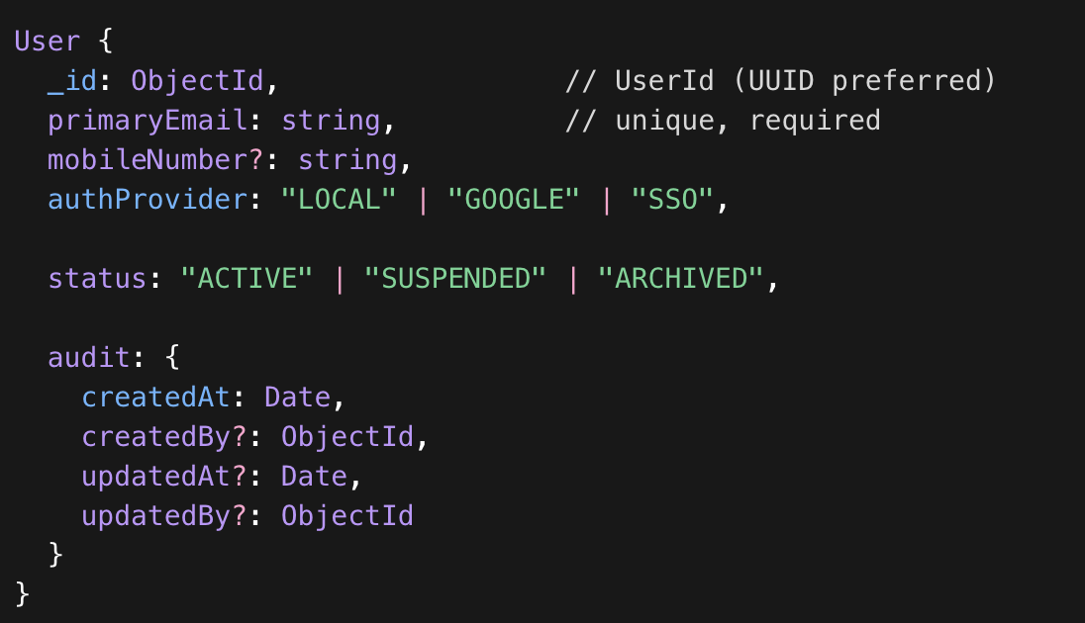
Indexes
- Unique index on primaryEmail
- Index on status
Rules
- Email must be globally unique.
- User is never hard deleted.
- ARCHIVED only in extreme cases (fraud, duplication).
2️ Authorization Context
Collection: user_role_assignments
Defines what a user can do and where.
Schema
UserRoleAssignment {
_id: ObjectId,
userId: ObjectId, // ref users._id
roleType: string, // enum (see below)
contextType: "COLLEGE" | "COMPANY" | "CLUB" | "SYSTEM",
contextId: ObjectId, // ID of college/company/club
effectiveFrom: Date,
effectiveTo?: Date,
status: "ACTIVE" | "REVOKED" | "EXPIRED",
audit: {
createdAt: Date,
createdBy?: ObjectId,
updatedAt?: Date,
updatedBy?: ObjectId
}
}
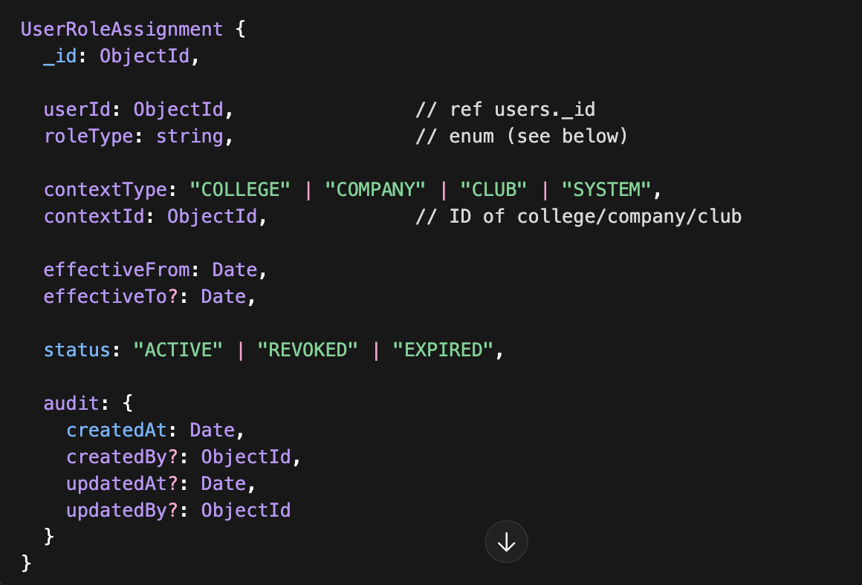
Indexes
- Index on (userId, status)
- Index on (contextType, contextId)
- Index on (userId, contextType, contextId)
Rules
- One ACTIVE role per (userId + roleType + contextId)
- Role cannot be ACTIVE if context entity is ARCHIVED.
- Role is ended by setting status = REVOKED and effectiveTo.
3️ Academic Context
Collection: student_profiles
Represents a student identity inside a college.
Schema
StudentProfile {
_id: ObjectId,
userId: ObjectId,
collegeId: ObjectId,
enrollmentNumber: string,
branch: string,
yearOfStudy: number,
cgpa?: number,
skills: string[],
certifications: ObjectId[], // ref WRCF certifications
wrcfProgress?: number,
engagementScore?: number,
status: "ACTIVE" | "GRADUATED" | "DROPPED" | "SUSPENDED",
audit: {
createdAt: Date,
createdBy?: ObjectId,
updatedAt?: Date,
updatedBy?: ObjectId
}
}
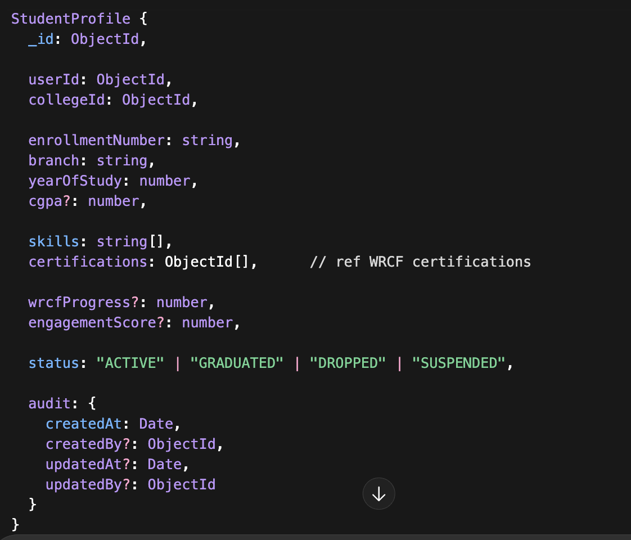
Indexes
- Unique (userId, collegeId)
- Index on collegeId
- Index on status
Rules
- One ACTIVE StudentProfile per user per college.
- Never deleted.
- Graduation is status change.
4️ Corporate Context
Collection: employee_profiles
Represents employment in a company.
Schema
EmployeeProfile {
_id: ObjectId,
userId: ObjectId,
companyId: ObjectId,
employeeCode: string,
department: string,
designation: string,
grade?: string,
reportingManagerId?: ObjectId,
dateOfJoining: Date,
employmentStatus:
"ACTIVE" | "ON_PROBATION" | "RESIGNED" | "TERMINATED" | "RETIRED",
audit: {
createdAt: Date,
createdBy?: ObjectId,
updatedAt?: Date,
updatedBy?: ObjectId
}
}
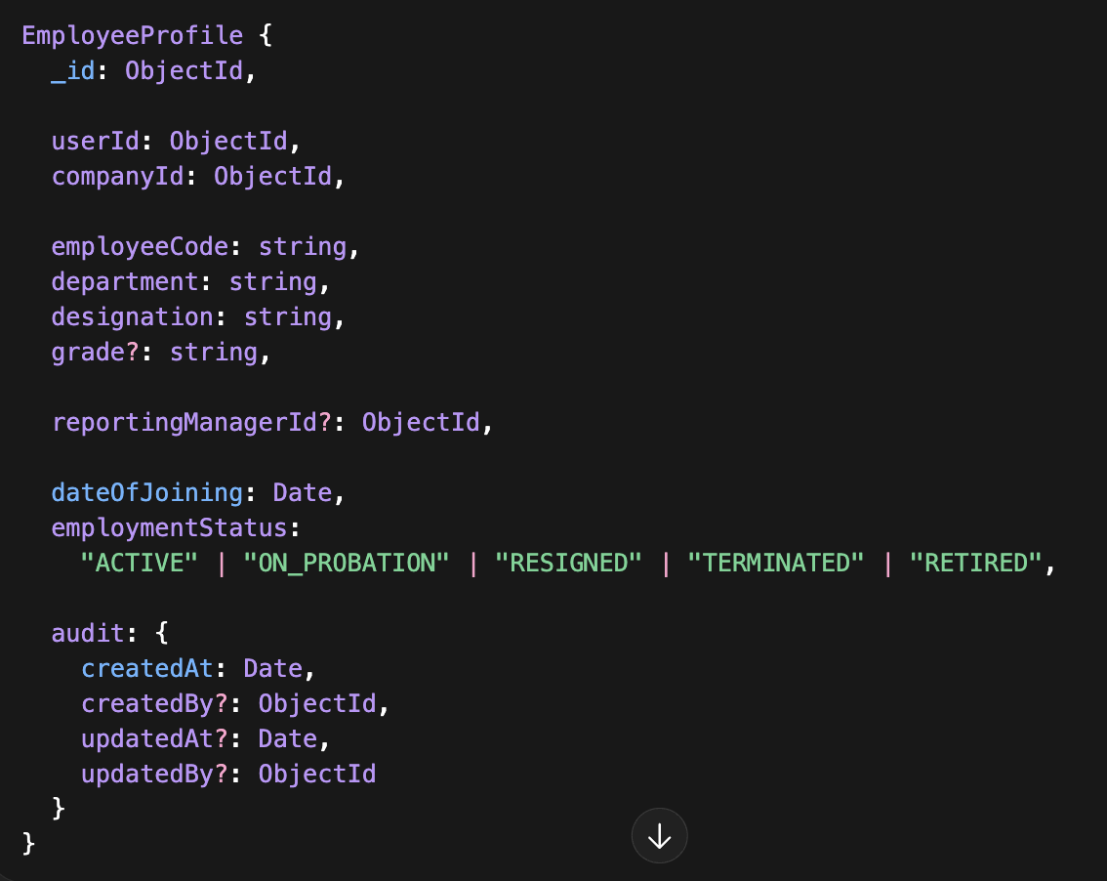
Indexes
- Unique (userId, companyId)
- Index on companyId
- Index on employmentStatus
Rules
- One ACTIVE employment per company per user.
- Resignation is status transition.
- Never hard delete.
5️ College Staff Context
Collection: college_employee_profiles
CollegeEmployeeProfile {
_id: ObjectId,
userId: ObjectId,
collegeId: ObjectId,
department: string,
designation: string,
employmentType: "PERMANENT" | "CONTRACT",
joiningDate: Date,
status: "ACTIVE" | "RESIGNED" | "TERMINATED",
audit: {
createdAt: Date,
createdBy?: ObjectId,
updatedAt?: Date,
updatedBy?: ObjectId
}
}
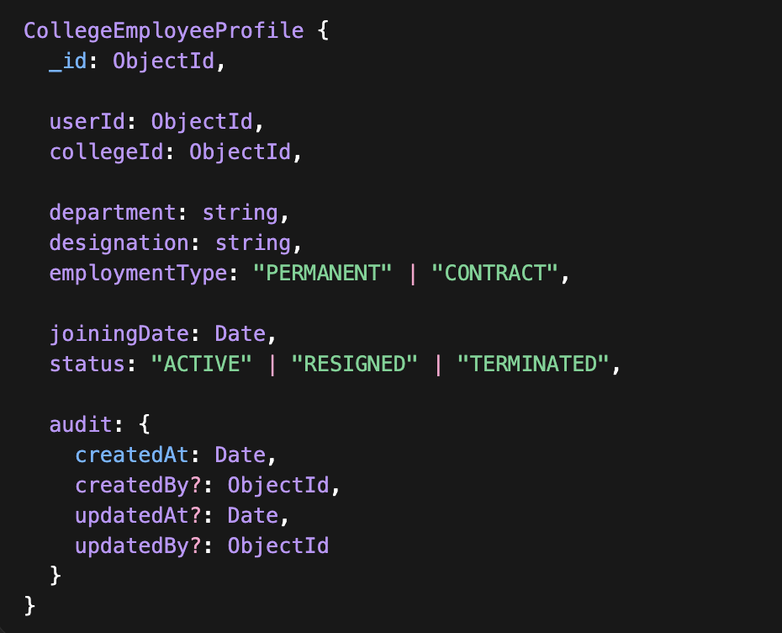
Unique (userId, collegeId).
6️ Club Context
Collection: club_memberships
ClubMembership {
_id: ObjectId,
userId: ObjectId,
clubId: ObjectId,
role:
"MEMBER" | "PRESIDENT" |
"CORE_TEAM" | "CONTENT_MANAGER" |
"COMMUNICATION_MANAGER",
joinedOn: Date,
contributionScore?: number,
status: "ACTIVE" | "REMOVED" | "INACTIVE",
audit: {
createdAt: Date,
createdBy?: ObjectId,
updatedAt?: Date,
updatedBy?: ObjectId
}
}
Unique (userId, clubId).
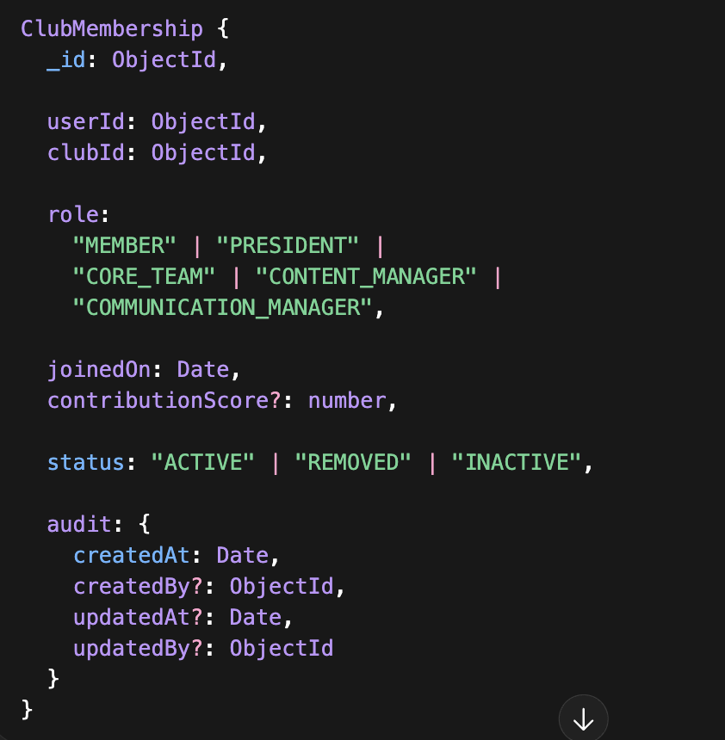
7️ RoleType Enum (Centralized)
Maintain a shared constant list:
STUDENT
ALUMNI
COLLEGE_ADMIN
PLACEMENT_OFFICER
CLUB_COORDINATOR
COMPANY_ADMIN
HR_MANAGER
HR_HEAD
FUNCTIONAL_HEAD
MANAGER
SUPERVISOR
ENGINEER
OPERATOR
TRAINEE
CLUB_ADMIN
CLUB_CORPORATE_COORDINATOR
CONTENT_MANAGER
COMMUNICATION_MANAGER
8️ Deletion Strategy (Finalized)
We will NOT hard delete identity or profile entities.
Final Policy
Entity | Strategy
User | status = ARCHIVED
RoleAssignment | status = REVOKED
StudentProfile | lifecycle status change
EmployeeProfile | employmentStatus change
CollegeEmployeeProfile | status change
ClubMembership | status change
No hard deletes except:
- Temporary system test data
- Or GDPR-driven legal purge (special admin process)
9️ Lifecycle Transition Example
Student → Employee
- StudentProfile status remains ACTIVE or GRADUATED.
- Create Placement record.
- Create EmployeeProfile.
- Create Company RoleAssignment.
- Optional: create ALUMNI role assignment.
UserId never changes.
For EmployeeProfile:
employmentStatus:
- Active
- OnProbation
- Resigned
- Terminated
- Retired
For StudentProfile:
studentStatus:
- Active
- Graduated
- Dropped
- Suspended
🔟 Final Collection Summary
You will have:
- users
- user_role_assignments
- student_profiles
- employee_profiles
- college_employee_profiles
- club_memberships
- placements (separate)
This is clean.
Scalable.
DDD-aligned.
Lifecycle-safe.

3.1.3 Functional Requirements
3.1.3.1 Parent Club Management
FR-CA-001
The system shall allow System Admin to create, edit, activate, or deactivate Parent Clubs.
FR-CA-002
Each Parent Club shall be mapped to an Industry domain.
FR-CA-003
Parent Club configuration shall include:
- Name
- Industry
- Description
- Governance settings
- Status (Active/Inactive)
FR-CA-004
Deactivation of a Parent Club shall not delete historical student or company data.
3.1.3.2 Club Management
FR-CA-005
The system shall allow Club Admin to create multiple Clubs under a Parent Club.
FR-CA-006
Each Club shall define:
- Certification levels (minimum 1, configurable maximum)
- Enrollment rules
- Assessment rules
- Completion criteria
FR-CA-007
The system shall enforce that a Club must belong to exactly one Parent Club.
FR-CA-008
Club Admin shall be able to define exploration rules (e.g., students may explore up to three clubs).
3.1.3.3 Workforce Readiness Capability Framework (WRCF) Management
FR-CA-009
Club Admin shall be able to define WRCF structure as per below.
FR-CA-NEW-001
Club Admin shall define Primary Work Objects (PWO) under Functional Groups.
FR-CA-NEW-002
Each PWO shall contain multiple Secondary Work Objects (SWO).
FR-CA-NEW-003
Capabilities shall be mapped to SWO.
FR-CA-NEW-004
Proficiency levels shall be configurable per Capability.
FR-CA-NEW-005
Each Skill shall contain:
Multiple Tasks
Associated Control Points
Evidence rules
FR-CA-010
Role Definitions shall assign multiple Capability Instances. A Capability Instance shall be defined as:
(SWO + Capability + Proficiency Level).
FR-CA-011
All framework modifications shall be version-controlled.
FR-CA-012
The system shall maintain a historical audit trail of framework changes.
FR-CA-013
Framework baseline definitions shall not be directly editable by Company-level users without version approval.
Sector, Industry, and Industry Reference Model Management
Req ID | Requirement | Priority | Acceptance criteria
FR-SEC-01 | The platform shall allow Club Industry expert to create, update, and retire Sectors with descriptions and metadata. | Must | Sector CRUD available with audit trail; retired sectors cannot be selected for new industries.
FR-IND-01 | The platform shall allow authorized Club Industry Expert to create and manage Industries under a Sector, including external taxonomy codes (e.g., NAICS/ISIC/GICS) as attributes. | Must | Industry can store multiple taxonomy mappings with source and effective date.
FR-IRM-01 | The platform shall support Industry Reference Models (IRMs) as versioned templates for function groups, PWO, SWO, capabilities, Proficiencies, skills, task and evidences | Must | An IRM version can be created as draft, reviewed, and published as immutable; versions have status and changelog.
FR-IRM-02 | The platform shall support creation of Company under Industry. Company admin than can create Departments and Roles under company. Roles shall be mapped to the Capability instances | Must | An IRM version can be created as draft, reviewed, and published as immutable; versions have status and changelog.
FR-IRM-03 | The platform shall provide diff and impact analysis between IRM versions (added/changed/retired nodes and mappings). | Should | Diff report identifies affected roles, competencies, and mapped learning experiences.

Company Configuration via Inheritance
Req ID | Requirement | Priority | Acceptance criteria
FR-COMP-01 | The platform shall support multi-tenant Companies, each linked to one Industry and one IRM version as baseline. | Must | Company creation requires selecting industry + IRM version; stored as references.
FR-COMP-02 | The platform shall bootstrap a company’s departments, and roles by instantiating the selected IRM version. | Must | After bootstrap, company has instance nodes with template references and correct relationships.
FR-COMP-03 | Company administrators shall be able to override selected fields of inherited nodes (e.g., names, descriptions, owner metadata) without modifying the IRM. | Must | Override creates a tenant-level delta record; effective model reflects override; IRM remains unchanged.
FR-COMP-04 | Company administrators shall be able to extend the model by adding new departments /roles / mapping of Capability instances that optionally reference existing templates or stand alone. role templates may be reused across industries. | Must | Extensions appear in the effective model and can participate in mappings and learning plans.
FR-COMP-05 | The platform shall support company configuration export/import (JSON) for audit, migration, and backup. | Should | Export includes IRM version reference + tenant deltas; import restores equivalent effective configuration.

3.1.3.4 Certification Architecture Management
FR-CA-014
Club Admin shall define Certification Levels (e.g., Level 1 to Level 4).
FR-CA-015
Each Certification Level shall define:
- Required capabilities
- Required skill thresholds
- Required project completion
- Required assessment scores
FR-CA-016
The system shall enforce evidence-based certification advancement.
FR-CA-017
Certification logic shall automatically validate completion criteria before upgrade approval.
3.1.3.5 Corporate Onboarding & Management
FR-CA-018
Club Corporate Manager shall onboard Companies under a Parent Club.
FR-CA-019
Company onboarding shall capture:
- Company name
- Industry mapping
- Contact details
- Billing details
- Subscription package
FR-CA-020
The system shall allow configuration of corporate pricing plans.
FR-CA-021
The system shall track corporate sponsorships and annual subscriptions.
FR-CA-022
Deactivation of a company shall not delete historical internship or hiring records.
3.1.3.6 Content Provider Management
FR-CA-023
Club Content Manager shall onboard content service providers.
FR-CA-024
Service providers may be assigned:
- Courses
- Projects
- Training programs
- Events
FR-CA-025
The system shall allow assignment of content to specific certification levels.
FR-CA-026
Content modifications shall not invalidate historical student records.
3.1.3.7 Project & Event Governance
FR-CA-027
Club Admin shall create and manage industry-level projects.
FR-CA-028
Projects shall be mappable to specific capabilities and skills.
FR-CA-029
The system shall allow corporate-sponsored projects.
FR-CA-030
The system shall track project status (Draft, Active, Completed, Archived).
3.1.3.8 Communication Governance
FR-CA-031
Club Communication Manager shall moderate club-level social feeds.
FR-CA-032
The system shall allow role-scoped visibility of posts.
FR-CA-033
The system shall log moderation actions.
FR-CA-034
Communication privileges shall be club-bound and permission-driven.
3.1.3.9 Analytics & Reporting
FR-CA-035
The system shall provide dashboards for:
- Student enrollment per club
- Certification progression rates
- Corporate participation
- Internship conversion rates
FR-CA-036
Club Admin shall view industry-wide readiness trends.
3.1.3.10 Billing & Sponsorship Governance
FR-CA-037
The system shall allow creation of pricing tiers for corporate packages.
FR-CA-038
The system shall support invoicing and payment tracking.
FR-CA-039
Corporate advertisement campaigns shall be configurable with duration and scope.
3.1.3.11 Role-Based Access Control (RBAC)
FR-CA-040
The system shall enforce role-based access restrictions for all Club Admin users.
FR-CA-041
No Club-level user shall access data outside their Parent Club scope.
FR-CA-042
All administrative actions shall generate audit logs.
3.1.4 Data Integrity Requirements
- All framework changes must be versioned.
- Historical certification data must remain immutable.
- Corporate sponsorship records must be auditable.
- Deactivation shall not delete dependent records.
- Student progress records must not be editable by Club Admin after certification approval.
3.1.5 Workflow Constraints
- Certification upgrade requires:
  - Evidence validation
  - System verification of thresholds
  - Optional manual approval workflow
- Company onboarding requires:
  - Subscription plan selection
  - Approval by Club Corporate Manager
- Framework modification requires:
  - Draft state
  - Review state
  - Published state
3.1.6 Security Requirements (Club Admin App)
- Multi-factor authentication for governance roles.
- Role hierarchy enforcement.
- Audit trail logging.
- Data encryption in transit.
- Tenant isolation enforcement.
3.1.7 Non-Functional Expectations (Club Admin App)
- High availability
- Framework update consistency
- Scalability across multiple industries
- Minimal latency for dashboard access
- Secure handling of corporate billing data

3.2 Student App
3.2.1 Introduction
The Student App functions as the Execution and Signal Generation Layer of the Whizard ecosystem.
It enables students to:
- Explore clubs
- Enroll in structured certification pathways
- Complete courses and projects
- Build capability evidence
- Participate in events
- Apply for internships and jobs
- Interact within Whizard Social
- Track readiness progression
All student actions must be capability-mapped and evidence-backed.
The Student App does not define standards — it operates within governance defined by the Club Admin App.
3.2.2 Actors
- Student
- Local Chapter Club Executive
- Alumni
All permissions shall be governed via RBAC.
3.2.3 Functional Requirements
A. Student Onboarding & Profile Management
3.2.3.1 Student Registration
FR-SA-001
The system shall allow students to register using:
- Institutional email OR
- Verified onboarding by College Admin
FR-SA-002
The system shall capture:
- Personal details
- Academic year
- College
- Degree program
- Interests
FR-SA-003
The system shall map each student to exactly one College entity.
3.2.3.2 Student Profile
FR-SA-004
The system shall maintain a structured student profile including:
- Certifications
- Capability progression
- Projects completed
- Internship history
- Assessment scores
- Job applications
FR-SA-005
Students shall not be able to manually edit certified capability scores.
B. Club Exploration & Enrollment
3.2.3.3 Club Exploration Stage
FR-SA-006
Students shall be allowed to explore up to a configurable maximum number of clubs (default: 3).
FR-SA-007
Exploration access shall allow:
- Viewing club overview
- Viewing certification structure
- Viewing sample projects
- Viewing skill requirements
FR-SA-008
Exploration participation shall not count toward certification progression unless enrolled.
3.2.3.4 Primary Club Selection
FR-SA-009
Students shall be required to select one primary club for structured certification progression.
FR-SA-010
Once selected, switching primary clubs shall follow configurable rules.
FR-SA-011
The system shall enforce certification progression within one primary club at a time.
C. Certification Progression
3.2.3.5 Enrollment in Certification Level
FR-SA-012
Students shall enroll in Certification Level 1 upon joining primary club.
FR-SA-013
Enrollment in higher levels shall require completion validation of lower levels.
3.2.3.6 Certification Advancement
FR-SA-014
The system shall validate:
- Required capabilities
- Required skill thresholds
- Required projects
- Required assessments
before advancing a student to the next level.
FR-SA-015
Certification upgrades may require manual approval where configured.
FR-SA-016
Students shall receive notification upon certification advancement.
D. Courses & Learning Modules
3.2.3.7 Course Enrollment
FR-SA-017
Students shall enroll in courses mapped to their certification level.
FR-SA-018
The system shall track:
- Course progress
- Assessment scores
- Completion status
FR-SA-019
Course completion shall update mapped capability records.
E. Projects & Capability Evidence
3.2.3.8 Project Participation
FR-SA-020
Students shall enroll in projects aligned with certification requirements.
FR-SA-021
Projects shall be mapped to:
- Capabilities
- Skills
- Evidence types
FR-SA-022
Students shall submit deliverables via structured submission interface.
3.2.3.9 Project Evaluation
FR-SA-023
Project evaluations shall update:
- Skill scores
- Capability scores
- Evidence records
FR-SA-024
Students shall not modify evaluation results.
FR-SA-025
Project history shall remain permanently recorded.
F. Events & Contests
3.2.3.10 Event Participation
FR-SA-026
Students shall register for club events and contests.
FR-SA-027
Event participation may generate:
- Participation certificates
- Skill evidence
- Ranking metrics
G. Mentorship
3.2.3.11 Mentor Interaction
FR-SA-028
Students shall request mentorship sessions.
FR-SA-029
Mentorship sessions may be:
- Scheduled
- Logged
- Feedback-recorded
H. Internship & Job Applications
3.2.3.12 Internship Application
FR-SA-030
Students shall apply to internships for which they meet eligibility criteria.
FR-SA-031
Eligibility may depend on:
- Certification level
- Skill thresholds
- Capability requirements
FR-SA-032
The system shall track:
- Application status
- Shortlisting
- Interview stages
- Offer status
3.2.3.13 Internship Evaluation
FR-SA-NEW-001
Students shall be assigned Tasks by supervisor based on role wise Capability Instance.
FR-SA-NEW-002
Students shall upload Evidence per Task.
FR-SA-NEW-003
Evidence types may include:
Documents
Simulation logs
Field verification
Supervisor sign-off
Video/photo proof
FR-SA-NEW-004
Tasks shall be marked complete only after Evaluator approval.
FR-SA-NEW-005
Skill shall be marked achieved only after:
All tasks completed
All control points validated
Evidence approved
FR-SA-NEW-006
Capability Instance shall be marked achieved only after all Skills under it are certified.
FR-SA-NEW-007
Role Readiness shall be auto-computed when all assigned Capability Instances are certified.
FR-SA-033
Internship performance shall update:
- Capability evidence
- Skill progression
FR-SA-034
Internship records shall be visible to placement cell and authorized companies.
3.2.3.14 Job Application
FR-SA-035
Students shall apply for full-time roles.
FR-SA-036
Job eligibility shall be system-validated.
FR-SA-037
Offer acceptance shall be logged.
I. Job Readiness Index
3.2.3.15 Readiness Score
FR-SA-038
The system shall compute a Job Readiness Index (JRI) based on:
- Certification level
- Capability coverage
- Project depth
- Internship evaluations
- Assessment scores
FR-SA-039
Students shall view their JRI dashboard.
FR-SA-040
JRI calculation logic shall not be editable by students.
J. Whizard Social
3.2.4 Whizard Social Communities
3.2.4.1 Club-Based Communities
FR-SA-SOC-001
Students enrolled in a Club shall automatically join:
- College-level club community
- Club community (same interest across India)
FR-SA-SOC-002
Students shall view and interact with peers from other colleges enrolled in the same Club.
3.2.4.2 Community Content
Students may:
- Share internship experiences
- Post project demos
- Share company interview insights
- Publish learning reflections
- Post college life experiences
- Share achievement milestones
3.2.4.3 Peer-to-Peer Learning
FR-SA-SOC-003
Students shall:
- Comment
- Like
- Collaborate
- Co-create project threads
- Form peer groups within club domain
3.2.5 Official College Communication Platform
Whizard Social shall act as the official campus communication hub.
3.2.5.1 Broadcast Messaging
FR-SA-SOC-004
College Admin shall broadcast:
- Placement updates
- Exam notifications
- Event announcements
- Internship drives
- Certification deadlines
FR-SA-SOC-005
Students shall receive:
- In-app notifications
- Push notifications
- Email (if enabled)
3.2.5.2 Event Calendar
FR-SA-SOC-006
Students shall access a real-time gamified event calendar.
Calendar shall include:
- Club events
- Trainings
- Internships
- Contests
- Placement drives
- Certification deadlines
3.2.6 Engagement & Gamification Engine
This is critical because engagement drives the Employability Index indirectly.
3.2.6.1 Engagement Score
System shall compute Engagement Score based on:
- Event participation
- Post interactions
- Peer collaboration
- Content contributions
- Challenge participation
3.2.6.2 Social Contribution Scoring
Engagement shall contribute to Club Points under:
“Social Platform Activity”
Points shall follow weighted structure already defined in College App.
Participation → Completion → Excellence logic applies.
3.2.6.3 Challenges & Competitions
FR-SA-SOC-007
System shall host:
- Weekly challenges
- National competitions
- Skill contests
- Hackathons
- Peer-voted demo showcases
3.2.6.4 Showcase Profile
Students shall maintain a public profile including:
- Club achievements
- Certifications
- Internship experiences
- Projects
- Contest wins
- Engagement highlights
This becomes visible to:
- Companies
- Mentors
- Peers
3.2.7 Collaboration & Competition
3.2.7.1 Cross-College Collaboration
Students may:
- Form project teams across colleges
- Collaborate in club challenges
- Co-submit innovation demos
3.2.7.2 Peer Recognition
Students may:
- Nominate peers for excellence
- Endorse project contributions
- Vote on best demo posts
Excellence recognition contributes to “Excellence” component of Club Points.
3.2.8 Analytics & Feedback Engine
This is where Student App connects to College App intelligence.
3.2.8.1 Participation Tracking
System shall track:
- Event attendance
- Certification attempts
- Task completion
- Internship engagement
- Social activity
3.2.8.2 Skill Progress Dashboard
Students shall view:
- Capability Instances completed
- Skills certified
- Tasks pending
- Role readiness %
3.2.8.3 Engagement Heatmap
Students shall see:
- Engagement vs peers
- Engagement percentile
- Growth recommendations
3.2.8.4 AI-Powered Trending Topics
FR-SA-SOC-008
System shall use ML models to:
- Surface trending discussion topics
- Highlight high-value internship threads
- Recommend relevant posts based on club interest
3.2.9 Feedback & Placement Intelligence
3.2.9.1 Internship Experience Repository
Students shall:
- Log internship experiences
- Upload insights
- Rate internship quality
- Share interview process details
Collective intelligence grows over time.
3.2.9.2 Placement Preparation Signals
System shall:
- Recommend trainings based on weak skill areas
- Alert student if Employability Index below branch threshold
- Suggest improvement path
3.2.10 Community Moderation & Governance
3.2.10.1 Moderation Controls
- ClubExec can moderate club-level posts.
- College Admin can moderate college-wide posts.
- Central Admin can moderate national threads.
3.2.10.2 Anti-Spam & Integrity
- Automated content filtering
- Abuse reporting
- Audit logs
3.2.11 Employability Signal Amplification
Whizard Social amplifies:
- Demonstrated excellence
- Skill mastery evidence
- Internship performance
- Peer recognition
Student’s public signal becomes:
Not just certification-based
But community-recognized competence-based.
3.2.12 Integration with Employability Index
Social & Engagement activity feeds:
- Social Platform Activity score
- Engagement Score
- Excellence recognition score
- Contest performance metrics
These update Club Points → Employability Index → College Ranking.
Strategic Upgrade Summary
Student App now operates as:
- Skill Execution Layer
- Social Capital Builder
- Official Campus Communication Channel
- Engagement Scoring Engine
- Internship Knowledge Repository
- Employability Signal Amplifier
- National Peer Network

K. Local Chapter Club Executive Privileges
3.2.14 Chapter Management
FR-SA-044
Local Chapter Club Executives may:
- Coordinate events
- Approve local participation
- Communicate with club members
FR-SA-045
Chapter Executives shall not modify certification logic.
L. Alumni Access
3.2.15 Alumni Permissions
FR-SA-046
Alumni shall:
- Access historical records
- Participate in mentorship
- Engage in Whizard Social
FR-SA-047
Alumni shall not enroll in new certification pathways.
3.2.4 Data Integrity Requirements
- Certification records must be immutable once awarded.
- Project evaluation records must be auditable.
- Internship ratings must be preserved permanently.
- Students cannot edit skill scores.
- Historical club participation must be retained.
3.2.5 Workflow Constraints
- Certification advancement must be rule-validated.
- Internship eligibility must be system-verified.
- Job eligibility must be threshold-based.
- Evidence must exist before capability score updates.
- Switching primary club must follow governance rules.
3.2.6 Security Requirements (Student App)
- Authentication required for all actions.
- Students may access only their own records.
- Role escalation prohibited.
- All submissions must be timestamped.
- Application data must be encrypted in transit.
3.2.7 Non-Functional Requirements (Student App)
- High concurrency support
- Real-time progress updates
- Low-latency dashboard loading
- Secure document upload handling
- Scalable storage for project submissions

3.3 College App
3.3.1 Introduction
The College App functions as the Institutional Integration and Monitoring Layer of the Whizard ecosystem.
It enables colleges to:
- Onboard students
- Launch and manage local club chapters
- Upload academic transcripts
- Monitor student progression
- View job readiness analytics
- Coordinate internships with companies
- Track placement pipelines
The College App does not define capability standards.
It operates within the governance defined by the Club Admin App and leverages student data generated through the Student App.
Actors
- College Admin
- Placement Cell
- Club Coordinator
Access shall be governed through RBAC.
3.3.2 Functional Requirements
A. College Onboarding & Profile Management
3.3.2.1 College Registration
FR-CO-001
The system shall allow onboarding of a College by Club Admin
FR-CO-002
College profile shall include:
- Institution name
- Accreditation details
- Contact information
- Authorized administrators
- Program offerings
FR-CO-003
A College shall operate as a distinct tenant within the platform.
3.3.3 Student Onboarding & Management
3.3.3.1 Student Registration
FR-CO-001
College Admin shall onboard students individually or via bulk upload.
The system shall validate uploaded data for:
- Duplicate entries
- Invalid identifiers
- Missing mandatory fields
FR-CO-002
Student attributes shall include:
- Stream
- Branch
- Academic Year
- Contact details
- Enrollment status
- Login status
FR-CO-003
System shall track onboarding status:
- Not Joined
- Joined
- Logged In
- Onboarded
3.3.3.2 Student Status Tracking
FR-CO-004
College Admin shall filter students by:
- Stream
- Branch
- Year
- Status
FR-CO-005
System shall maintain full onboarding audit logs.
Transcript Upload
College Admin shall upload semester-wise academic transcripts.
Transcript data may include:
- GPA/CGPA
- Subject-level scores
- Backlog indicators
Transcript data shall be stored as structured academic records. Transcript uploads shall not override student capability scores.
3.3.4 Club Onboarding & Governance
3.3.4.1 Club Chapter Creation
FR-CO-006
College Admin shall launch local chapters mapped to Parent Clubs.
FR-CO-007
Each chapter shall assign:
- President
- Vice Presidents
- Secretary
- Treasurer
3.3.4.2 Representative Governance
FR-CO-008
System shall maintain club office bearer records per academic cycle.
FR-CO-009
Performance of club leadership shall reflect in club-level performance analytics.
3.3.5 Employability Index & Club Points Engine
This is the core upgrade.
3.3.5.1 Employability Index Definition
Student Employability Index shall be computed based on:
Weighted Club Points earned across activities.
Weightage Order (High → Low):
- Job Trainings
- Internships
- Events
- Certification Levels
  - Assessments
  - Projects
  - Courses
- Club Exploration & Joining
- Social Platform Activity
3.3.5.2 Club Points Composition
For each activity, points shall be computed using:
Where:
- Participation (Initiation) = 10%
- Completion (Effort) = 40%
- Excellence (Demonstrated & Recognized Skill) = 50%
3.3.5.3 Activity Weight Governance
FR-CO-010
Activity weights shall be configurable at system level.
FR-CO-011
Higher weighted activities (e.g., Job Training, Internship) shall contribute disproportionately to the Employability Index.
3.3.5.4 Student Employability Index Calculation
FR-CO-012
System shall compute:
- Branch-level average Employability Index
- Year-level distribution
- College-level index score
3.3.6 Student Progress Tracking
3.3.6.1 Individual Student Dashboard
System shall display:
- Club Score
- Certification Status
- Training Participation
- Internship Status
- Final Selection Status
- Employability Tier:
  - Achiever
  - On Track
  - Growth Needed
3.3.6.2 Branch-wise Performance
FR-CO-013
College shall view branch-wise:
- Training selection count
- Placement offers
- Certification levels
- Average branch score
3.3.7 Placement Dashboard & Funnel Analytics
3.3.7.1 Placement Metrics
System shall track:
- Total Students
- Students Placed
- Students Pending
- Placement Rate
- Internship Placement Rate
- Paid Internship %
- Average Salary
- Highest Salary
3.3.7.2 Placement Funnel
FR-CO-014
System shall display Journey to Placement Funnel:
Stages:
- Profile Completed
- Internship Done
- Training Attended
- Drive Applied
- Placement
Drop-off percentage shall be calculated at each stage.
3.3.7.3 Placement by Salary Range
System shall categorize placements by:
- Salary slabs
- Industry type
- Internship vs Job
Internship Mid-term feedback Coordination
Functional Managers from companies shall submit internship feedback.
Placement Cell shall access mid-term and final evaluation reports.
Feedback shall update student capability evidence automatically.
3.3.8 Club Performance Dashboard
3.3.8.1 Club Enrollment Metrics
System shall display:
- Total Clubs
- Enrollment Rate
- Engagement Score
- Achievers %
- On Track %
- Room for Growth %
3.3.8.2 Club Points Screen
For each club:
System shall show:
- Avg Engagement Score
- Avg Club Points
- Avg Certification Score
- Event Scores
- Social Engagement
- Exploration Score
3.3.8.3 Individual Club Student Listing
System shall show:
- Login Status
- Engagement Score
- Club Points
- Social Activity
- Event Participation
- Certification Status
3.3.9 Student Progress Categorization
System shall classify students:
- Achiever (High Employability Index)
- On Track
- Growth Needed
Thresholds configurable.
3.3.10 College Ranking Engine
3.3.10.1 Ranking Metrics
College Ranking shall consider:
- Placement Rate
- Internship Completion
- Employability Index Average
- Certification Levels Achieved
- Club Engagement Rate
- High Achiever %
3.3.10.2 Multi-Level Ranking
System shall support:
- District Ranking
- State Ranking
- Zone Ranking
- National Ranking
3.3.10.3 Performance Breakdown
College performance areas:
- Club Enrollment
- High Achievers
- On Track %
- Growth Needed %
- Placement Rate
- Internship Completion %
3.3.11 Placement Logbook Access
FR-CO-015
Placement Cell shall access student internship logbooks.
FR-CO-016
Placement Cell shall view company-wise internship outcomes.
3.3.12 Predictive Placement Analytics
FR-CO-017
System shall predict:
- Expected placement rate
- Branch risk indicators
- Students at placement risk
- Certification gap impact on placement probability
3.3.13. Communication & Notifications
3.3.13.1 College Communication
FR-CO-018
College Admin shall broadcast announcements to:
- All students
- Specific club members
- Specific academic year groups
FR-CO-019
College-level posts shall be visible only within the institution.
3.3.14 Corporate Interaction Visibility
3.3.14.1 Company Engagement Overview
FR-CO-020
Placement Cell shall view:
- Companies tied to the College
- Active internships
- Active job requisitions
- Historical hiring trends
3.3.14.2 Student Application Visibility
FR-CO-021
Placement Cell shall view application statuses of students.
FR-CO-022
College users shall not interfere with company hiring decisions.
3.3.12 Data Integrity & Governance
- Club Points once awarded cannot be modified without audit trail.
- Excellence score must be tied to certified achievement.
- Placement data must be verified via company confirmation.
- Ranking computations must be version-controlled.
- Transcript uploads must preserve version history.
- Internship feedback must remain immutable once submitted.
- College-level analytics must be read-only derived data.
- Student certification records must not be editable by college users.
- Student academic records must be auditable.
3.3.4 Structural Summary
College App operates as:
- Student onboarding system
- Club governance platform
- Employability computation engine
- Placement intelligence dashboard
- Ranking & benchmarking system
- Predictive institutional analytics layer
3.3.5 Workflow Constraints
- Student onboarding requires data validation.
- Local chapter creation requires Club-level approval.
- Internship feedback must follow company submission.
- Job readiness index is system-calculated and read-only.
- Placement Cell visibility is role-restricted.
3.3.6 Security Requirements (College App)
- Institutional data isolation.
- Role-based access within college.
- Secure bulk upload validation.
- Audit trail logging for:
  - Student onboarding
  - Transcript uploads
  - Chapter creation
- No cross-college data visibility.
3.3.7 Non-Functional Requirements (College App)
- Scalable student data handling
- Real-time analytics dashboard refresh
- Secure document storage
- High availability during placement season
- Performance optimized for bulk data upload

3.4 Company App
3.4.1 Introduction
The Company App functions as the Industry Integration and Talent Absorption Layer of the Whizard ecosystem.
It enables companies to:
- Onboard and manage organizational structure
- Customize capability requirements aligned to industry baseline
- Post internships and job requisitions
- Evaluate interns and candidates
- Sponsor projects and events
- Run advertisement campaigns
- Provide conditional offer training
- Track hiring analytics
- Manage billing and subscriptions
It is designed to:
- Replace or significantly augment traditional L&D systems
- Reduce hiring risk through capability-verifiable evaluation
- Convert learning spend into measurable workforce readiness
- Provide AI-powered skill intelligence
- Build a continuous college-to-enterprise talent pipeline
- Serve as an immediate go-to resource for company-specific problem solving
Traditional systems (LMS, generic courses, interview-based hiring) produce low-confidence outcomes. Whizard instead operates on:
- Workforce Readiness Capability Framework (WRCF)
- AI-driven skill intelligence
- Multi-agent simulations
- Work-object mastery validation
- Evidence-based capability scoring
The Company App operates within capability frameworks governed by the Club Admin App and interacts with student-generated performance data.

3.4.2 Enterprise Capability Architecture
The Company App extends the WRCF into enterprise execution.
It allows companies to:
- Map internal roles to industry roles
- Define role competence thresholds
- Track workforce capability coverage
- Identify skill gaps at organization level
- Drive AI-personalized upskilling
- Validate learning via work-object simulation
3.4.2.1 Actors
- Company Admin
- HR Head
- Recruitment Manager
- Functional Manager
- Training Manager
- Department Head
- Department Manager
All permissions shall be governed via RBAC.
3.4.3 Functional Requirements
A. Company Onboarding & Organizational Setup
3.4.3.1 Company Registration
FR-CM-001
The system shall allow onboarding of a Company by club Admin under the respective Industry.
FR-CM-002
Company profile shall include:
- Company name
- Industry
- Registered address
- Billing details
- Subscription package
- Authorized user (company Admin details)
FR-CM-003
Each company shall operate as an isolated tenant within the platform.
3.4.3.2 Organizational Structure Setup
FR-CM-004
Company Admin shall map Departments and Role Positions to WRCF baseline Role Definitions.
FR-CM-005
Departments shall be mapped to Functional Groups defined in the Workforce Readiness Capability Framework (WRCF).
FR-CM-006
Company Admin shall create internal users and assign role-based permissions.
B. Industry Reference Models and Company Inheritance
Industry Reference Models and Company Inheritance
To avoid configuring each company separately, the platform must support Industry Reference Models (IRMs): versioned templates that define a generic WRCF for an industry. Companies instantiate an IRM version to produce a tenant-specific configuration, then optionally override or extend elements while retaining lineage.
​​Company Instantiation and Override Model
- Instantiation creates Company-specific instances that inherit from template nodes.
- Three change types are supported: Adopt (no change), Override (modify fields), Extend (add new child nodes).
- Overrides do not mutate the IRM; they apply at tenant scope only and maintain a reference to the template source.
- Effective configuration is computed by merging IRM + tenant overrides + extensions with deterministic precedence (tenant > IRM).
Inheritance and Override Rules
1. Template nodes are read-only for tenant users; only curators can modify IRM drafts and publish versions.
2. Tenant overrides must retain template references and cannot violate core constraints (e.g., cannot change entity type).
3. Deletion of inherited nodes is expressed as a tenant-level 'retire' flag with reason and audit trail (soft delete), not physical removal.
4. Upgrading IRM versions must never auto-delete tenant-created extensions; conflicts are resolved through explicit mapping or duplication with lineage.

3.4.3.3 Role Mapping
FR-CM-007
Company Admin shall define company-specific Role Positions.
FR-CM-008
Each Role Position shall map to baseline Industry Roles from WRCF.
FR-CM-009
Company Admin may add additional skill requirements without altering industry baseline definitions.
Role Competence Engine
FR-CM-NEW-008
Role shall define required Capability Instances and may need to customize the industry baseline by adding / deleting certain Capability Instances.
FR-CM-NEW-009
System shall track per employee:
- Skills completed (as per the Capability instances assigned for the role)
- Pending tasks
- Evidence status
- Role readiness percentage
FR-CM-NEW-010
Employee becomes “Role Competent” only when all capability instances are certified.
3.4.3.4 Capability Customization
FR-CM-010
Company may:
- Adjust required skill thresholds
- Add company-specific competencies
- Define minimum certification level eligibility
FR-CM-011
Customizations shall be version-controlled and auditable. Baseline Industry definitions shall not be editable by Company users.
3.4.3.5 Enterprise Skill Gap Identification
FR-CM-012
The system shall analyze employee capability data to identify:
- Skill gaps
- Role readiness gaps
- Promotion readiness indicators
- Organizational risk areas
The system shall provide department-level skill gap dashboards
C. Internship Management
3.4.3.5 Internship Requisition Creation
FR-CM-013
Department Manager shall create Internship Requisitions.
FR-CM-014
Internship requisition shall define:
- Role position
- Required certification level
- Required capability thresholds
- Internship duration
- Location (On-site/Hybrid/Remote)
- Stipend details
- Week wise Skills and Task assignment as per the capability instances attached to the Role.
3.4.3.6 Internship Approval Workflow
FR-CM-015
Internship requisition shall require approval by:
- Department Head
- HR Head (if configured)
FR-CM-016
Only approved requisitions shall be visible to eligible students.
3.4.3.7 Application Management
FR-CM-017
Recruitment Manager shall:
- View eligible applicants
- Shortlist candidates
- Schedule interviews
- Record interview outcomes
FR-CM-018
Application statuses shall include:
- Applied
- Shortlisted
- Interview Scheduled
- Selected
- Rejected
- Offer Extended
- Offer Accepted
3.4.3.8 Internship Evaluation
FR-CM-019
Functional Manager shall submit:
- Mid-term feedback
- Final evaluation
- Capability ratings
- Internship performance score
FR-CM-020
Evaluators shall review submitted evidence against Task / Control Points.
FR-CM-NEW-005
Evaluator shall:
Approve
Reject
Request revision
FR-CM-NEW-006
Approval shall update Skill certification status.
FR-CM-NEW-007
The system shall maintain evaluator identity and timestamp.
FR-CM-021
Internship evaluation once submitted shall be immutable.
D. Job Management
3.4.3.9 Job Requisition Creation
FR-CM-022
Department Manager shall create Job Requisitions.
FR-CM-023
Job requisitions shall define:
- Role position
- Required certification level
- Required capability coverage
- Compensation range
- Location
3.4.3.10 Job Approval Workflow
FR-CM-024
Job requisitions shall require:
- Department Head approval
- HR Head approval
3.4.3.11 Candidate Selection
FR-CM-025
Recruitment Manager shall manage:
- Shortlisting
- Interview scheduling
- Interview feedback logging
- Offer extension
FR-CM-026
Offer acceptance shall be recorded in the system.
E. Training & Conditional Offers
3.4.3.12 Conditional Offer Training
FR-CM-027
Training Manager shall create:
- Training programs
- Assignments
- Assessments
FR-CM-028
Training may be assigned to:
- Interns
- Conditional offer candidates
- Existing employees
3.4.3.13 Training Evaluation
FR-CM-029
Training completion shall generate:
- Assessment score
- Competency rating
- Certification (if applicable)
F. AI-Powered Personalized Learning & Reskilling
3.4.3.14 Personalized Learning Path Generation
FR-CM-030
AI engine shall generate personalized learning paths based on:
- Current capability score
- Target role requirements
- Career trajectory
- Performance data
FR-CM-031
Learning paths shall dynamically adjust based on assessment outcomes.
3.4.3.15 Dynamic Content Creation
FR-CM-032
AI shall assist in generating:
- Refresher training modules
- Scenario-based simulations
- Role-specific micro-learning units
- Assessment questions
- Case studies
FR-CM-033
Generated content shall be tagged to capabilities and skills.
3.4.3.16 Work-Object Simulation
FR-CM-034
The system shall simulate real company work objects (e.g., troubleshooting scenarios, operational cases).
FR-CM-035
Simulation outcomes shall generate verifiable evidence of mastery.
This replaces passive LMS consumption with active capability validation.
G. Refresher & On-Demand Knowledge System
3.4.3.17 Enterprise Problem-Solving AI Assistant
FR-CM-036
Employees shall query company-specific knowledge through AI-assistant.
FR-CM-037
The assistant shall provide:
- SOP references
- Troubleshooting flows
- Best practices
- Capability-linked guidance
3.4.3.7 Continuous Refresher Training
FR-CM-038
Training Manager shall assign refresher programs mapped to:
- Capability decay risk
- Regulatory updates
- Process changes
FR-CM-039
Completion shall update capability freshness indicators.
H. Hiring Risk Reduction
3.4.3.19 Capability-Based Candidate Evaluation
FR-CM-040
Hiring decisions shall be based on:
- Verified certification levels
- Capability coverage
- Internship simulation results
- Work-object evidence
FR-CM-041
AI shall generate capability gap reports for shortlisted candidates.
3.4.3.20 Internship as Predictive Hiring Model
FR-CM-042
Internship evaluations shall map directly to the role readiness index.
FR-CM-043
System shall calculate Internship-to-Role Predictive Score.
I. Continuous Talent Pipeline
3.4.3.21 College-to-Enterprise Pipeline Tracking
FR-CM-044
Companies shall track:
- Talent pool pipeline by certification level
- College-wise readiness distribution
- Future hiring pipeline visibility
3.4.3.22 Early Capability Engagement
FR-CM-045
Companies may sponsor:
- Capability-aligned challenges
- Simulation competitions
- Problem-based events
This ensures early alignment of student capability to company need.
J. Project Sponsorship
3.4.3.23 Sponsored Projects
FR-CM-046
Recruitment Manager shall sponsor projects under Clubs.
FR-CM-047
Sponsored projects shall be mapped to defined capabilities.
FR-CM-048
The company shall receive performance analytics of participating students.
K. Advertisement & Branding
3.4.3.24 Ad Campaign Management
FR-CM-049
Company Admin shall create advertisement campaigns & sponsorships.
Create / Manage Sponsorship: Options to sponsor a skill club event, place an ad on the platform, or highlight a brand message.
Create New Campaign leads to a form for specifying sponsorship type, event details (if sponsoring a real-world event), ad creative uploads, and budget details. Campaign List shows each sponsorship or ad item, with performance metrics (impressions, clicks, or conversions).

Ad Campaign Dashboard: Track impressions, clicks, and overall ROI for ads placed on the platform.

FR-CM-050
Ads may target:
- Specific Clubs
- Specific Certification Levels
- Specific Colleges
FR-CM-051
Campaign duration and billing shall be configurable.
L. Analytics & Talent Insights
3.4.3.25 Talent Pool Access
FR-CM-052
Companies shall access filtered talent pools based on:
- Certification level
- Capability coverage
- College
- Internship ratings
3.4.3.26 Hiring Analytics Dashboard
FR-CM-053
System shall provide:
- Application volume trends
- Offer conversion rates
- Internship-to-full-time conversion rate
- Capability gap analysis
3.4.3.27 Workforce Intelligence Dashboard
System shall provide:
- Department capability heatmaps
- Role readiness index
- Promotion readiness signals
- Skill decay alerts
- Training ROI metrics
- Hiring risk score
M. Billing & Subscription Management
3.4.3.28 Subscription Management
FR-CM-054
Company Admin shall manage subscription plans.
Package Selection / Purchase: Allows the recruitment manager to purchase or upgrade packages for posting credits, priority placement, or sponsorships.
Payment History: Overview of all payments, invoices, usage of purchased credits.
Current Plan and usage (e.g., 5 postings used out of 10 available).
Available Packages
- RPO (Recruitment process Outsourcing) Plan packages with tiered pricing
- Training Plan (Inclusive of RPO)
- Add-on Plans: Enhanced Brand Promotion (while will provide additional opportunity to campaign over Social and/or Project / Events / Club sponsorship.
FR-CM-055
System shall generate invoices for:
- Annual subscription
- Sponsored projects
- Ad campaigns
FR-CM-056
Payment status shall be tracked.
N. Company Page Management
Individuals Profile Settings: Recruitment manager Uploads his profile pic, Bio, detailed profile and role at the current company,
Company Profile Settings: Upload logo, brand assets, company summary, mission/vision.
Content Management: Post articles, short updates, success stories, or upcoming events.
Engagement Metrics: Track visits, follower count, candidate engagement.
Edit Company Profile: upload logo/banner, set tagline, add a description or mission
statement.

Post Article: share news, events, success stories; can appear on the company
page or across the platform.
Manage Gallery: control images or media that appear to showcase your brand.
O. Data Governance & Restrictions
3.4.3.29 Access Control
FR-CM-057
Company users shall access only their organization’s data.
FR-CM-058
Company users shall not modify:
- Industry baseline framework
- Student evaluation records outside their internships
3.4.4 Data Integrity Requirements
- Internship evaluations must be immutable.
- Hiring records must be auditable.
- Framework customizations must be versioned.
- Offer records must be permanently stored.
- Billing records must comply with financial audit standards.
3.4.5 Workflow Constraints
- Internship and job requisitions must follow approval workflow.
- Eligibility validation must be automated.
- Capability updates must be evidence-driven.
- Training evaluation must be score-based.
- No hiring status may bypass defined states.
3.4.6 Security Requirements (Company App)
- Role-based permission hierarchy.
- Secure candidate data handling.
- Multi-factor authentication for HR Head.
- Audit logs for hiring decisions.
- Encrypted billing data.
3.4.7 Non-Functional Requirements (Company App)
- High availability during campus hiring season.
- Secure document upload for resumes and evaluations.
- Fast candidate filtering performance.
- Scalable analytics engine.
- Secure financial transaction handling.

4. External Interface Requirements
4.1 Introduction
This section defines all external interface requirements for the Whizard platform.
Whizard shall support integration with third-party systems to enable:
- Communication
- Video collaboration
- Artificial intelligence services
- Enterprise authentication
- Professional profile verification
- Course content delivery
All integrations shall be managed through the Whizard API Gateway and shall comply with security, privacy, and data isolation requirements.
4.2 System Interface Requirements
Whizard shall expose and consume RESTful APIs via a centralized API Gateway.
4.2.1 API Gateway Requirements
ER-SI-001
The system shall expose secure API endpoints for third-party integrations.
ER-SI-002
All external integrations shall route through the API Gateway.
ER-SI-003
The API Gateway shall enforce:
- Authentication
- Authorization
- Rate limiting
- Request validation
- Logging
ER-SI-004
All API communication shall use HTTPS with TLS encryption.
4.3 Communication Interfaces
4.3.1 Email Integration
ER-COM-001
The system shall integrate with third-party email service providers (e.g., SendGrid, SES, etc.).
ER-COM-002
Email notifications shall support:
- Account activation
- Certification updates
- Internship application updates
- Job offer notifications
- Billing notifications
ER-COM-003
Email templates shall be configurable.
4.3.2 SMS Integration
ER-COM-004
The system shall integrate with SMS gateway providers.
ER-COM-005
SMS notifications shall support:
- OTP verification
- Interview reminders
- Offer alerts
ER-COM-006
SMS delivery logs shall be stored for audit purposes.
4.3.3 In-App Notifications
ER-COM-007
The system shall provide real-time in-app notifications.
ER-COM-008
Notification preferences shall be configurable per user.
4.4 Video Conferencing Integration
Whizard shall integrate with external video conferencing platforms.
Supported platforms may include:
- Zoom
- Google Meet
- Microsoft Teams
4.4.1 Meeting Creation
ER-VC-001
Authorized users shall create meeting links directly from Whizard.
ER-VC-002
The system shall generate meeting invitations with:
- Date
- Time
- Participants
- Role context (Interview / Mentorship / Training)
4.4.2 Authentication & Token Handling
ER-VC-003
Integration shall use OAuth 2.0 authentication.
ER-VC-004
Meeting tokens shall not be stored in plaintext.
4.4.3 Meeting Metadata
ER-VC-005
Meeting metadata (link, time, participants) shall be stored within Whizard.
ER-VC-006
The system shall not store video recordings unless explicitly configured.
4.5 AI API Integrations
Whizard shall integrate with AI service providers including:
- OpenAI (ChatGPT APIs)
- Anthropic (Claude / Opus APIs)
- Future AI provider APIs
4.5.1 AI Use Cases
AI integrations may support:
- Resume analysis
- Capability gap analysis
- Interview question generation
- Skill assessment generation
- Certification pathway recommendations
- Content summarization
- Automated evaluation assistance
4.5.2 API Usage Requirements
ER-AI-001
All AI API calls shall pass through backend servers (no direct client calls).
ER-AI-002
Sensitive student data shall be masked or minimized before transmission.
ER-AI-003
AI outputs shall not automatically override human evaluation decisions.
ER-AI-004
AI recommendations shall be marked as advisory.
4.5.3 Data Privacy Guardrails
ER-AI-005
Personally identifiable information (PII) shall not be sent unless necessary.
ER-AI-006
AI response logs shall be stored securely for audit where applicable.
4.6 Single Sign-On (SSO) Integration
Whizard shall support enterprise authentication integrations.
4.6.1 Corporate HRMS Integration
ER-SSO-001
The system shall support SSO using:
- SAML 2.0
- OAuth 2.0
- OpenID Connect
ER-SSO-002
Corporate users shall authenticate using their HRMS credentials.
ER-SSO-003
Role mapping shall be configurable during SSO onboarding.
4.6.2 College ERP Integration
ER-SSO-004
Colleges shall integrate via SSO with ERP systems.
ER-SSO-005
Student identity verification shall support:
- ERP ID mapping
- Batch synchronization
4.6.3 Provisioning & De-Provisioning
ER-SSO-006
The system shall support automated user provisioning.
ER-SSO-007
Deactivated ERP/HRMS users shall lose Whizard access automatically.
4.7 LinkedIn Integration
Whizard shall integrate with LinkedIn APIs (subject to LinkedIn API policy compliance).
4.7.1 Mentor Profile Import
ER-LI-001
Mentors may connect LinkedIn accounts to import:
- Name
- Designation
- Company
- Experience summary
- Profile photo
4.7.2 Verification
ER-LI-002
LinkedIn data shall be used for informational purposes only.
ER-LI-003
Profile updates shall require user consent.
4.7.3 Data Storage
ER-LI-004
Imported LinkedIn data shall not be redistributed outside the platform.
4.8 Course Content Integration
Whizard shall integrate with external learning platforms.
Examples:
- LMS platforms
- MOOC providers
- SCORM-compliant systems
- Proprietary content providers
4.8.1 Content Access
ER-CC-001
Students may access external course content via secure redirection or embedded modules.
ER-CC-002
The system shall track:
- Course start
- Progress
- Completion
4.8.2 Content Standards
ER-CC-003
Integration shall support:
- SCORM
- xAPI
- LTI (Learning Tools Interoperability)
4.8.3 Completion Sync
ER-CC-004
External completion data shall update capability records automatically.
ER-CC-005
Course completion data must be verifiable and auditable.
4.9 Security & Compliance Requirements
All external integrations shall comply with:
- TLS encryption
- OAuth 2.0 / SAML authentication
- API rate limiting
- Data masking where required
- Audit logging
- Tenant data isolation
4.10 Failure Handling & Resilience
ER-FH-001
External service failure shall not cause system-wide outage.
ER-FH-002
Retry mechanisms shall be implemented for transient failures.
ER-FH-003
Users shall receive graceful error notifications.
4.11 Performance Requirements
- External API response timeout thresholds must be defined.
- AI API latency must not block critical workflows.
- Notification dispatch must occur within defined SLA.
- SSO login latency must be within acceptable enterprise standards.
4.12 Integration Governance Principles
- All integrations must pass through the API Gateway.
- No client-side direct third-party API calls.
- No uncontrolled PII sharing.
- AI outputs are advisory, not authoritative.
- Corporate SSO must respect tenant isolation.

5. Non-Functional Requirements
5.1 Introduction
This section defines the non-functional requirements (NFRs) for the Whizard platform.
These requirements govern:
- Performance
- Scalability
- Security
- Availability
- Reliability
- Compliance
- Maintainability
- Auditability
These requirements apply across all four applications:
- Club Admin App
- Student App
- College App
- Company App
5.2 Performance Requirements
5.2.1 Response Time
NFR-PERF-001
The system shall respond to standard user interactions within ≤ 2 seconds under normal load.
NFR-PERF-002
Dashboard loading time shall not exceed 3 seconds for standard datasets.
NFR-PERF-003
Search and filtering operations shall return results within ≤ 2 seconds for datasets up to defined thresholds.
5.2.2 Concurrent Users
NFR-PERF-004
The system shall support concurrent usage by:
- ≥ 10,000 active students per tenant
- ≥ 1,000 concurrent internship/job applications during peak placement cycles
NFR-PERF-005
The system shall handle peak loads during:
- Certification result announcements
- Campus hiring seasons
- Internship application deadlines
5.2.3 AI & External API Latency
NFR-PERF-006
AI-assisted workflows shall not block critical system operations.
NFR-PERF-007
External API timeouts shall be configurable.
5.3 Scalability Requirements
5.3.1 Horizontal Scalability
NFR-SCAL-001
The system architecture shall support horizontal scaling of:
- Application servers
- API gateways
- Database clusters
5.3.2 Multi-Tenant Scalability
NFR-SCAL-002
The platform shall support onboarding of:
- Multiple industries
- Multiple Parent Clubs per industry
- Multiple colleges per club
- Multiple companies per industry
NFR-SCAL-003
Tenant data isolation shall not degrade performance across tenants.
5.3.3 Storage Scalability
NFR-SCAL-004
The system shall support scalable storage for:
- Project submissions
- Internship reports
- Course materials
- Transcript uploads
5.4 Availability Requirements
5.4.1 Uptime
NFR-AV-001
The system shall maintain ≥ 99.5% uptime annually.
NFR-AV-002
Planned maintenance windows shall be communicated in advance.
5.4.2 Fault Tolerance
NFR-AV-003
The system shall implement redundancy for:
- Application servers
- Database clusters
- Load balancers
NFR-AV-004
Failure of external integrations shall not cause system-wide outage.
5.4.3 Backup & Disaster Recovery
NFR-AV-005
Automated daily backups shall be maintained.
NFR-AV-006
Recovery Point Objective (RPO) shall not exceed 24 hours.
NFR-AV-007
Recovery Time Objective (RTO) shall be defined and documented.
5.5 Security Requirements
Security is a critical requirement due to:
- Student personal data
- Corporate hiring data
- Academic transcripts
- Financial billing records
5.5.1 Authentication & Authorization
NFR-SEC-001
All users shall authenticate using secure login mechanisms.
NFR-SEC-002
Multi-Factor Authentication (MFA) shall be mandatory for:
- System Admin
- Club Admin
- HR Head
- Company Admin
- College Admin
NFR-SEC-003
Role-Based Access Control (RBAC) shall be enforced across all modules.
5.5.2 Data Protection
NFR-SEC-004
All data in transit shall use TLS encryption.
NFR-SEC-005
Sensitive data at rest shall be encrypted.
NFR-SEC-006
Personally Identifiable Information (PII) shall be access-controlled.
5.5.3 Audit & Logging
NFR-SEC-007
The system shall log:
- Certification upgrades
- Internship evaluations
- Hiring decisions
- Framework modifications
- Billing transactions
NFR-SEC-008
Audit logs shall be tamper-resistant.
5.5.4 Session Management
NFR-SEC-009
User sessions shall expire after configurable inactivity periods.
NFR-SEC-010
Concurrent session control shall be configurable.
5.6 Data Privacy & Compliance
5.6.1 Regulatory Compliance
NFR-COMP-001
The system shall comply with applicable data protection regulations (e.g., GDPR-equivalent frameworks where applicable).
NFR-COMP-002
User consent shall be obtained before:
- Sharing student data with companies
- Importing LinkedIn data
- Sending promotional communications
5.6.2 Data Retention
NFR-COMP-003
Data retention policies shall be configurable.
NFR-COMP-004
Historical certification and internship records shall not be deleted.
5.6.3 Data Minimization
NFR-COMP-005
Only required data fields shall be transmitted to external APIs.
5.7 Reliability Requirements
NFR-REL-001
Critical workflows (internship application, certification advancement) shall be transactionally safe.
NFR-REL-002
System shall prevent partial state updates during failure scenarios.
NFR-REL-003
Retry mechanisms shall exist for transient external failures.
5.8 Usability Requirements
NFR-USAB-001
The system shall provide intuitive dashboards tailored to user roles.
NFR-USAB-002
Navigation shall not exceed three clicks for critical workflows.
NFR-USAB-003
Error messages shall be descriptive and actionable.
5.9 Maintainability Requirements
NFR-MAIN-001
The system shall use modular architecture to allow independent updates of components.
NFR-MAIN-002
Framework updates shall not require full system redeployment.
NFR-MAIN-003
Codebase shall support CI/CD pipelines.
5.10 Portability Requirements
NFR-PORT-001
The system shall operate across modern browsers.
NFR-PORT-002
The system shall be deployable in cloud-native environments.
5.11 Observability & Monitoring
NFR-OBS-001
The system shall monitor:
- API performance
- Error rates
- External integration failures
- Database health
NFR-OBS-002
Alerting mechanisms shall notify administrators of:
- System outages
- Security anomalies
- Integration failures
5.12 Business Continuity
NFR-BC-001
In case of infrastructure failure, the system shall support disaster recovery restoration.
NFR-BC-002
Critical hiring workflows shall be prioritized during partial degradation scenarios.
5.13 Ethical & AI Governance
NFR-AI-001
AI-generated recommendations shall be advisory.
NFR-AI-002
AI outputs shall not override final hiring or certification decisions.
NFR-AI-003
Bias monitoring mechanisms shall be documented for AI-assisted processes.
5.14 Non-Functional Summary
Whizard must operate as:
- A secure platform
- A scalable multi-tenant system
- A high-availability hiring infrastructure
- A compliance-aligned data ecosystem
- An audit-ready capability engine
Failure in non-functional quality directly compromises trust across:
- Students
- Colleges
- Companies
- Governance bodies
Evaluation Integrity Requirements
- Evidence must be immutable once approved.
- Evaluator identity must be stored.
- Control point validation must be auditable.
- Certification decisions must be traceable to task-level evidence.
- No automated certification without evidence.
This strengthens trust in competence validation.

6. Data Model & Entity Relationship Specification
6.1 Introduction
This section defines the conceptual and logical data model of the Whizard platform.
The data model supports:
- Multi-tenant governance
- Workforce Readiness Capability Framework (WRCF)
- Student progression tracking
- Internship & job lifecycle management
- Corporate customization
- Institutional monitoring
The data architecture shall ensure:
- Referential integrity
- Role-scoped data isolation
- Auditability
- Version control
- Historical record immutability
6.2 Core Data Domains
The Whizard data model consists of six primary domains:
- Governance Domain
- Capability Framework Domain
- Student Lifecycle Domain
- College Domain
- Company Domain
- Transactional & Audit Domain
6.3 Governance Domain
6.3.1 Entities
6.3.1.1 Industry
- IndustryID (PK)
- Name
- Description
- Status
6.3.1.2 ParentClub
- ParentClubID (PK)
- IndustryID (FK)
- Name
- GovernanceConfig
- Status
6.3.1.3 Club
- ClubID (PK)
- ParentClubID (FK)
- Name
- CertificationStructure
- Status
6.3.2 Relationships
- One Industry → Many ParentClubs
- One ParentClub → Many Clubs
- One Club → Many CertificationLevels
6.4 Capability Framework Domain (WRCF)
This is the intellectual backbone of Whizard.
6.4.1 Hierarchical Structure
Industry
→ Functional Group
→ Primary Work Object (PWO)
→ Secondary Work Object (SWO)
→ Capability
→ Proficiency
→ Skill
→ Task
→ Control Point
→ Evidence
→ Evaluator
6.4.2 Entities
6.4.2.1 FunctionalGroup
- FunctionalGroupID (PK)
- IndustryID (FK)
- Name
- Description
PrimaryWorkObject (PWO)
- PWOID (PK)
- FunctionalGroupID (FK)
- Name
- Description
SecondaryWorkObject (SWO)
- SWOID (PK)
- PWOID (FK)
- Name
- Description
6.4.2.3 Capability
- CapabilityID (PK)
- Name
- Description
CapabilityInstance
- CapabilityInstanceID (PK)
- FunctionalGroupID (FK)
- PWOID (FK)
- SWOID (FK)
- CapabilityID (FK)
- ProficiencyLevel
- RequiredFlag
Proficiency
- ProficiencyID (PK)
- Name
- Description
6.4.2.4 Skill
- SkillID (PK)
- CapabilityInstanceID (FK)
- Name
- Description
Task
- TaskID (PK)
- SkillID (FK)
- Description
- AssignedBy
- Deadline
- Status
TaskAssignment
- TaskAssignmentID (PK)
- TaskID (FK)
- PersonID (Student/Employee FK)
- AssignedDate
- CompletionStatus
ControlPoint
- ControlPointID (PK)
- TaskID (FK)
- ValidationCriteria
- MandatoryFlag
Evidence
- EvidenceID (PK)
- TaskAssignmentID (FK)
- UploadedBy
- EvidenceType
- FileReference
- SubmittedDate
Evaluation
- EvaluationID (PK)
- EvidenceID (FK)
- EvaluatorID
- Status
- Comments
- Timestamp
SkillCertification
- SkillCertificationID (PK)
- PersonID
- SkillID
- CertifiedBy
- CertifiedDate
CapabilityInstanceCertification
- CapabilityInstanceCertificationID (PK)
- PersonID
- CapabilityInstanceID
- Status
- CertifiedBy
- CertifiedDate
6.4.2.2 RoleDefinition
- RoleID (PK)
- FunctionalGroupID (FK)
- Name
- Description
- Version
RoleCompetenceRecord
- RoleCompetenceRecordID (PK)
- PersonID
- RoleID
- CompetenceStatus
- CompletionDate
6.4.3 Versioning Model
- RoleDefinitionVersion
- CapabilityVersion
- SkillVersion
Framework updates shall create new version records without overwriting historical data.
6.5 Certification Domain
6.5.1 Entities
6.5.1.1 CertificationLevel
- CertificationLevelID (PK)
- ClubID (FK)
- LevelNumber
- RequiredCapabilities
- MinimumThresholds
6.5.1.2 CertificationRecord
- CertificationRecordID (PK)
- StudentID (FK)
- CertificationLevelID (FK)
- AwardDate
- Status
- VersionReference
6.5.2 Relationships
- One Club → Many CertificationLevels
- One Student → Many CertificationRecords
- CertificationRecord must reference framework version used during evaluation
6.6 Student Lifecycle Domain
6.6.1 Entities
6.6.1.1 Student
- StudentID (PK)
- CollegeID (FK)
- PrimaryClubID (FK)
- AcademicYear
- Status
6.6.1.2 StudentCapabilityScore
- StudentCapabilityScoreID (PK)
- StudentID (FK)
- CapabilityID (FK)
- Score
- LastUpdated
6.6.1.3 StudentSkillScore
- StudentSkillScoreID (PK)
- StudentID (FK)
- SkillID (FK)
- Score
- EvidenceReference
6.6.1.4 Project
- ProjectID (PK)
- ClubID (FK)
- CapabilityMapping
- Status
6.6.1.5 ProjectSubmission
- SubmissionID (PK)
- StudentID (FK)
- ProjectID (FK)
- SubmissionDate
- EvaluationScore
6.6.2 Internship & Job Domain
6.6.2.1 InternshipRequisition
- InternshipID (PK)
- CompanyID (FK)
- RolePositionID (FK)
- Status
6.6.2.2 InternshipApplication
- ApplicationID (PK)
- StudentID (FK)
- InternshipID (FK)
- Status
- ApplicationDate
6.6.2.3 InternshipEvaluation
- EvaluationID (PK)
- ApplicationID (FK)
- CapabilityScoreUpdate
- FinalRating
6.6.2.4 JobRequisition
- JobID (PK)
- CompanyID (FK)
- RolePositionID (FK)
- Status
6.6.2.5 JobApplication
- JobApplicationID (PK)
- StudentID (FK)
- JobID (FK)
- Status
6.7 College Domain
6.7.1 Entities
6.7.1.1 College
- CollegeID (PK)
- Name
- Accreditation
- Status
6.7.1.2 CollegeUser
- CollegeUserID (PK)
- CollegeID (FK)
- RoleType
6.7.1.3 AcademicTranscript
- TranscriptID (PK)
- StudentID (FK)
- Semester
- GPA
- UploadedDate
6.8 Company Domain
6.8.1 Entities
6.8.1.1 Company
- CompanyID (PK)
- ParentClubID (FK)
- SubscriptionPlan
- Status
6.8.1.2 Department
- DepartmentID (PK)
- CompanyID (FK)
- FunctionalGroupMapping
6.8.1.3 RolePosition
- RolePositionID (PK)
- CompanyID (FK)
- RoleDefinitionID (FK)
- CustomThresholds
6.8.1.4 CompanyUser
- CompanyUserID (PK)
- CompanyID (FK)
- RoleType
6.8.2 Enterprise Workforce & L&D Domain
This section extends the data model to support:
- Post-hire employee lifecycle
- Internal role progression
- Skill gap analytics
- AI-personalized learning
- Simulation-based assessment
- Capability refresh tracking
- Promotion readiness scoring
6.8.3 Employee Domain
6.8.3.1 Employee
Represents a hired individual (may originate from Student entity or be externally onboarded).
Attributes:
- EmployeeID (PK)
- CompanyID (FK)
- LinkedStudentID (nullable FK)
- DepartmentID (FK)
- RolePositionID (FK)
- HireDate
- EmploymentStatus
- CareerTrack
- CreatedAt
Relationship
- One Company → Many Employees
- One Employee → One RolePosition (current)
- One Employee → Many RoleHistory records
6.8.3.2 RoleHistory
Tracks promotions and role transitions.
Attributes:
- RoleHistoryID (PK)
- EmployeeID (FK)
- PreviousRolePositionID
- NewRolePositionID
- EffectiveDate
- Reason (Promotion / Transfer / Lateral)
6.8.4 Employee Capability Domain
6.8.4.1 EmployeeCapabilityProfile
Represents capability coverage for an employee relative to role requirements.
Attributes:
- ProfileID (PK)
- EmployeeID (FK)
- RolePositionID (FK)
- CapabilityCoverageScore
- RoleReadinessScore
- GapIndex
- LastComputedDate
6.8.4.2 EmployeeCapabilityScore
Attributes:
- EmployeeCapabilityScoreID (PK)
- EmployeeID (FK)
- CapabilityID (FK)
- CurrentScore
- RequiredThreshold
- GapValue
- LastUpdated
6.8.4.3 SkillFreshnessRecord
Tracks skill decay and refresher needs.
Attributes:
- SkillFreshnessID (PK)
- EmployeeID (FK)
- SkillID (FK)
- LastValidatedDate
- FreshnessScore
- RefreshRequiredFlag
6.8.5 Skill Gap Intelligence
6.8.5.1 SkillGapReport
Generated via AI or analytics engine.
Attributes:
- ReportID (PK)
- EmployeeID (FK)
- GeneratedBy (AI / Manager)
- GeneratedDate
- GapSummary
- RiskLevel
- PromotionBlockerFlag
6.8.5.2 DepartmentCapabilityHeatmap
Aggregated analytics entity (materialized view).
Attributes:
- HeatmapID (PK)
- DepartmentID (FK)
- CapabilityID (FK)
- AverageCoverage
- GapSeverity
- LastUpdated
6.8.6 AI-Personalized Learning Domain
6.8.6.1 LearningPath
Represents a personalized capability development plan.
Attributes:
- LearningPathID (PK)
- EmployeeID (FK)
- TargetRolePositionID
- GeneratedBy (AI / TrainingManager)
- Status
- CreatedDate
6.8.6.2 LearningPathItem
Attributes:
- LearningPathItemID (PK)
- LearningPathID (FK)
- CapabilityID (FK)
- CourseID (nullable FK)
- SimulationID (nullable FK)
- PriorityLevel
- CompletionStatus
6.8.6.3 RefresherTrainingAssignment
Attributes:
- AssignmentID (PK)
- EmployeeID (FK)
- CapabilityID (FK)
- TriggerReason (SkillDecay / Regulation / RoleUpgrade)
- AssignedDate
- CompletionStatus
6.8.7 Simulation & Work-Object Validation
6.8.7.1 SimulationTemplate
Represents company-specific work-object simulation.
Attributes:
- SimulationID (PK)
- RolePositionID (FK)
- CapabilityMapping
- DifficultyLevel
- CreatedBy
- Version
6.8.7.2 SimulationAttempt
Represents employee/student execution of simulation.
Attributes:
- AttemptID (PK)
- SimulationID (FK)
- EmployeeID (nullable FK)
- StudentID (nullable FK)
- AttemptDate
- Score
- EvidenceGenerated
- EvaluationReference
6.8.7.3 SimulationEvidence
Attributes:
- EvidenceID (PK)
- AttemptID (FK)
- CapabilityID (FK)
- SkillID (FK)
- ScoreContribution
- VerifiedFlag
6.8.8 Enterprise Knowledge System
6.8.8.1 KnowledgeAsset
Represents SOPs, troubleshooting documents, training artifacts.
Attributes:
- KnowledgeAssetID (PK)
- CompanyID (FK)
- CapabilityID (FK)
- AssetType (SOP / Guide / Case / Video)
- Version
- VisibilityScope
6.8.8.2 KnowledgeQueryLog
Logs AI-powered enterprise assistant interactions.
Attributes:
- QueryLogID (PK)
- EmployeeID (FK)
- QueryText
- ResponseGenerated
- Timestamp
- LinkedKnowledgeAssetID (nullable FK)
6.8.9 Promotion Readiness Domain
6.8.9.1 PromotionEligibilityRecord
Attributes:
- PromotionRecordID (PK)
- EmployeeID (FK)
- TargetRolePositionID
- CapabilityCoverageScore
- SkillGapIndex
- SimulationPerformanceIndex
- AIRecommendationFlag
- FinalDecision
- DecisionDate

6.8.10 Extended Relationship Overview
Now the lifecycle looks like this:
Student
→ InternshipApplication
→ InternshipEvaluation
→ Employee
→ EmployeeCapabilityProfile
→ SkillGapReport
→ LearningPath
→ SimulationAttempt
→ PromotionEligibilityRecord
6.8.11 Cross-Domain Integrity Rules
- An Employee may originate from a Student record.
- EmployeeCapabilityProfile must reference the current RolePosition.
- SkillGapReport must reference capability threshold logic.
- LearningPath must map to defined CapabilityIDs.
- SimulationAttempt must generate evidence mapped to SkillIDs.
- PromotionEligibilityRecord must preserve a snapshot of capability state at evaluation time.
- No framework baseline changes shall retroactively alter historical EmployeeCapabilityScore records.
6.8.12 Extended Multi-Tenant Isolation
- Employee data is isolated by CompanyID.
- Knowledge assets are company-scoped.
- Simulation templates are company-scoped.
- AI learning path generation must not expose cross-company data.
- Student-to-Employee linkage must respect consent and compliance rules.
6.8.12 Architectural Evolution Summary
With these additions, Whizard now models:
- Pre-hire capability formation (Student domain)
- Hiring risk reduction (Internship & Job domain)
- Post-hire capability tracking (Employee domain)
- Continuous L&D replacement (LearningPath & Simulation domain)
- Promotion readiness & workforce intelligence (Promotion domain)
6.9 Communication Domain
6.9.1 Entities
6.9.1.1 Post
- PostID (PK)
- AuthorID
- ClubID (optional FK)
- VisibilityScope
- Content
- CreatedAt
6.9.1.2 Notification
- NotificationID (PK)
- RecipientID
- Type
- DeliveryChannel
- Status
6.10 Billing Domain
6.10.1 Entities
6.10.1.1 Subscription
- SubscriptionID (PK)
- CompanyID (FK)
- PlanType
- StartDate
- EndDate
6.10.1.2 Invoice
- InvoiceID (PK)
- CompanyID (FK)
- Amount
- Status
- PaymentReference
6.11 Audit & Logging Domain
6.11.1 Entities
6.11.1.1 AuditLog
- AuditID (PK)
- ActorID
- ActorType
- ActionType
- EntityAffected
- Timestamp
- PreviousValueHash
- NewValueHash
All critical state transitions must generate audit entries.
6.12 Key Relationship Summary (Cardinality Overview)
- One Industry → Many ParentClubs
- One ParentClub → Many Clubs
- One Club → Many CertificationLevels
- One Student → One PrimaryClub
- One Student → Many Certifications
- One Student → Many ProjectSubmissions
- One Student → Many InternshipApplications
- One Company → Many RolePositions
- One RolePosition → Many InternshipRequisitions
- One InternshipRequisition → Many Applications
- One Application → One Evaluation
6.13 Data Integrity Rules
- CertificationRecord is immutable once awarded.
- InternshipEvaluation cannot be edited after submission.
- Framework versions must be preserved.
- StudentSkillScore updates require evidence reference.
- Company customization cannot modify baseline framework records.
6.14 Multi-Tenant Isolation Model
- College data is scoped by CollegeID.
- Company data is scoped by CompanyID.
- Governance data is scoped by ParentClubID.
- Student data visibility is permission-bound.
- Cross-tenant queries must be restricted.
6.15 Historical Record Preservation
The system shall:
- Preserve historical certification state.
- Preserve framework version references.
- Preserve hiring records permanently.
- Maintain audit trails for all evaluative actions.
Section 6 Summary
The Whizard Data Model is:
- Hierarchical at governance layer
- Relational at execution layer
- Version-controlled at framework layer
- Immutable at certification layer
- Multi-tenant at organizational layer
- Auditable at transactional layer
This structure ensures:
- Capability integrity
- Hiring trust
- Institutional transparency
- Industry confidence

7. End-to-End Role Competence Lifecycle
7.1 Introduction
This section defines the complete lifecycle of an individual within the Whizard ecosystem, from student development to enterprise role competence and promotion.
The lifecycle enforces the following principles:
- Capabilities belong to the Industry.
- Competence belongs to the Role.
- Tasks validate Skills.
- Evidence validates Tasks.
- Supervisors certify Skills.
- Capability Instances determine Role Readiness.
- Role Competence determines Workforce Readiness.
The lifecycle spans:
Student → Internship → Employee → Task Assignment → Evidence → Certification → Role Competence → Promotion
7.2 Phase 1 – Student Capability Formation
7.2.1 Exploration & Enrollment
- Student selects Primary Club.
- Student enters certification pathway aligned to Functional Group and PWO.
- Student progresses through Capability Instances mapped to SWO + Capability + Proficiency.
7.2.2 Task-Level Learning
For each Capability Instance:
- System exposes associated Skills.
- Each Skill contains atomic Tasks.
- Tasks contain Control Points.
Student must:
- Execute Task
- Submit Evidence
- Await Evaluation
No skill is assumed. All skills must be demonstrated.
7.2.3 Skill Certification
Supervisor / Evaluator:
- Reviews evidence against Control Points
- Approves / rejects
- Certifies Skill upon approval
When all Skills under a Capability Instance are certified:
→ Capability Instance is certified.
When all required Capability Instances for a Student-level Role are certified:
→ Student is marked “Industry Role Ready (Pre-Hire)”.
7.3 Phase 2 – Internship Validation
7.3.1 Internship as Predictive Validation
During internship:
- Student is assigned real PWO/SWO context.
- Company Supervisor assigns operational Tasks.
- Student submits workplace Evidence.
- Evaluator validates performance.
Internship Evaluation updates:
- Skill scores
- Capability Instance strength
- Role readiness confidence score
Internship is treated as live environment validation of competence.
7.4 Phase 3 – Transition to Employee
7.4.1 Conversion Event
If hired:
- Student record links to Employee record.
- Certified Capability Instances transfer to EmployeeCapabilityProfile.
- RolePosition is assigned.
Employee begins enterprise lifecycle.
7.5 Phase 4 – Supervisor-Governed Enterprise Competence
7.5.1 Role Assignment
RolePosition defines:
- Required Capability Instances
- Required Proficiency Levels
- Mandatory Skills
- Control Rule set
EmployeeCapabilityProfile compares:
Required vs Achieved.
7.5.2 Task Assignment by Supervisor
Supervisor assigns:
- Tasks mapped to missing or upgrading Capability Instances
- Tasks aligned to real Primary/Secondary Work Objects
Each Task includes:
- Defined Control Points
- Deadline
- Evaluation rules
7.5.3 Evidence Submission
Employee must:
- Execute task in real operational environment
- Upload evidence (document, simulation log, approval, field verification)
Evidence is immutable once submitted.
7.5.4 Evaluation & Certification
Evaluator:
- Reviews evidence against Control Points
- Approves or rejects
- Certifies Skill upon success
System automatically updates:
- SkillCertification
- CapabilityInstanceCertification
- EmployeeCapabilityProfile
7.6 Phase 5 – Role Competence Determination
7.6.1 Capability Instance Completion Rule
Capability Instance is marked complete only when:
- All associated Skills certified
- All required proficiency levels achieved
- No mandatory Control Point pending
7.6.2 Role Competence Rule
RoleCompetenceRecord is generated when:
- All required Capability Instances for the Role are certified.
RoleCompetenceStatus = TRUE
Employee is now “Role Competent”.
7.7 Phase 6 – Continuous L&D & Skill Refresh
7.7.1 Skill Decay Monitoring
System tracks:
- SkillFreshnessRecord
- Time since last validation
- Regulatory update triggers
If freshness threshold breached:
→ RefresherTrainingAssignment is triggered.
7.7.2 AI-Generated Learning Path
AI analyzes:
- SkillGapReport
- TargetRolePosition
- Promotion eligibility
Generates:
- Personalized LearningPath
- Simulation assignments
- Refresher tasks
7.8 Phase 7 – Promotion Eligibility
7.8.1 Target Role Mapping
Promotion to higher role requires:
- New Capability Instances
- Higher Proficiency levels
- Additional SWO contexts
7.8.2 Promotion Evaluation Workflow
System generates PromotionEligibilityRecord containing:
- CapabilityCoverageScore
- SkillGapIndex
- SimulationPerformanceIndex
- Supervisor recommendations
- AI advisory signal
Final decision remains human-controlled.
7.9 Lifecycle Summary Diagram (Narrative Form)
- Student builds Capability Instances via Tasks & Evidence.
- Internship validates in live environment.
- Student converts to Employee.
- Supervisor assigns enterprise Tasks.
- Evidence evaluated.
- Skills certified.
- Capability Instances completed.
- Role Competence achieved.
- Skill freshness monitored.
- AI suggests upgrades.
- Promotion evaluated via new Capability Instances.
7.10 Control & Governance Rules
- No skill certification without evidence.
- No capability completion without certified skills.
- No role competence without certified capability instances.
- No promotion without verified role competence.
- All evaluations must be auditable.
- AI cannot auto-certify competence.
7.11 Enterprise Impact Model
This lifecycle ensures:
- Learning spend converts into measurable competence.
- Hiring risk is reduced through verified task evidence.
- Internship becomes predictive hiring filter.
- Promotion decisions are data-backed.
- L&D becomes continuous, contextual, and AI-assisted.
- Workforce readiness is transparent and auditable.
7.12 Strategic Conclusion
Whizard replaces fragmented systems by unifying:
- Academic preparation
- Industrial validation
- Supervisor evaluation
- AI-assisted development
- Promotion governance
Into one continuous Role Competence Engine.
This lifecycle transforms workforce development from:
Course Completion → Interview Guesswork
Into:
Task Execution → Evidence Validation → Capability Certification → Role Competence → Promotion Readiness

8 – Gamification & Behavioral Design Framework

8.1 Purpose
This section defines the behavioral architecture embedded within Whizard to:
Increase long-term student engagement
Encourage sustained skill mastery
Promote healthy competition
Drive measurable employability outcomes
Reduce disengagement and drop-off rates
Align intrinsic motivation with institutional objectives
Whizard gamification shall not be entertainment-based.
It shall be outcome-driven and mastery-aligned.
8.2 Design Principles
The Gamification Framework shall be based on:
1. Progress Visibility
2. Effort Recognition
3. Excellence Amplification
4. Peer Comparison (Constructive)
5. Long-Term Identity Formation
6. Signal Value Creation
Gamification shall always reinforce:
Capability → Evidence → Certification → Employability

8.3 Core Gamification Components
8.3.1 Club Points Engine
The primary gamification currency is Club Points.
Points are derived from:
This ensures:
Mere attendance is not rewarded heavily.
Completion matters.
Demonstrated excellence carries maximum weight.
8.3.2 Employability Index
The Employability Index shall:
Update dynamically
Be visible to student
Influence ranking
Affect placement prediction signals
Visibility drives motivation.
8.4 Progression System
8.4.1 Status Tiers
Students shall be categorized into tiers:
Growth Needed
On Track
Achiever
Elite Performer (optional extension)
Thresholds configurable by central governance.

Tier visibility must be:
Visible to student
Visible to college
Visible to recruiters (where applicable)
8.4.2 Visual Progress Indicators
Student dashboard shall include:
Progress bars for certification completion
Role readiness %
Engagement percentile
Skill mastery heatmap
Placement funnel stage indicator
Progress must be:
Immediate
Clear
Quantified
8.5 Competition Architecture
8.5.1 Leaderboards
Leaderboards shall exist at multiple levels:
Club-level leaderboard
Branch-level leaderboard
College-level leaderboard
National club leaderboard
Leaderboards shall display:
Club Points
Certification count
Internship completion
Excellence recognitions
8.5.2 Challenge System
System shall run:
Weekly micro challenges
Monthly skill contests
Inter-college competitions
Industry-sponsored problem statements
Completion of challenges shall:
Award bonus Club Points
Trigger Excellence multipliers
Increase Engagement Score
8.5.3 Healthy Competition Controls
To prevent negative behaviors:
Leaderboards may show percentile rather than exact ranking in early stages.
Growth improvements rewarded, not just absolute score.
No public shaming of low performers.
8.6 Social Capital Amplification
8.6.1 Public Recognition
System shall:
Highlight top contributors
Spotlight internship success stories
Feature project demos weekly
Display “Excellence Badges”
Badges must represent:
Skill mastery
Internship excellence
Challenge winner
Mentor recognition
Peer recognition
8.6.2 Peer Endorsements
Students may endorse:
Project collaboration
Skill demonstration
Internship performance
Endorsements shall contribute partially to Excellence weight component.
8.7 Streak & Consistency Mechanics
To drive long-term engagement:
Event attendance streak
Weekly activity streak
Task submission streak
Certification progression streak
Streak break notifications shall encourage re-engagement.
8.8 Placement Funnel Nudging
Behavioral nudges shall trigger when:
Student fails to complete profile
Student misses training
Certification incomplete
Internship opportunity ignored
Nudges may include:
Push notifications
Peer comparison alerts
“Students like you completed X” messaging
Placement risk warning
8.9 Behavioral Feedback Loop

8.9.1 Feedback Model
After each activity:
Student receives:
Points gained
Skill improvement impact
Employability index delta
Ranking movement
Immediate feedback strengthens reinforcement loop.
8.9.2 Positive Reinforcement
System shall:
Celebrate milestones
Provide achievement animations
Notify club peers of achievement
Issue digital certificates instantly

8.10 Institutional Gamification
Gamification applies not only to students, but to colleges.
8.10.1 College Ranking Score
College score shall depend on:
Average Employability Index
Placement Rate
Internship Completion Rate
High Achiever %
Club Engagement Rate
Colleges compete in:
District ranking
State ranking
Zone ranking
National ranking
8.10.2 Club Health Score
Each club shall have:
Engagement Score
Certification Completion Rate
Internship Conversion Rate
Leader Activity Index
Low-performing clubs trigger governance alerts.

8.11 Anti-Gaming Safeguards
To preserve system integrity:
1. Excellence component requires supervisor validation.
2. Certification cannot be auto-awarded.
3. Internship logs require evaluator confirmation.
4. Peer endorsements capped per user.
5. Sudden abnormal point spikes trigger audit.
8.12 Long-Term Identity Design
Whizard shall encourage:
“I am a Robotics Whizard”
“I am a Data Whizard”
Students build identity around:
Club mastery
Capability strength
Recognized excellence
Identity drives sustained participation beyond rewards.
8.13 Alignment with Workforce Readiness
Gamification must always reinforce:
Task completion
Evidence submission
Capability certification
Internship validation
Promotion readiness
Points without competence shall not exist.
8.14 Behavioral Success Metrics
System shall track:
4-year retention rate
Drop-off reduction %
Certification completion %
Internship participation %
Placement funnel conversion improvement
Engagement-to-placement correlation

9 – AI & Recommendation Intelligence Framework
9.1 Purpose
This section defines the Artificial Intelligence architecture embedded within Whizard to:
- Personalize student development pathways
- Predict placement outcomes
- Identify skill gaps
- Surface high-value content
- Optimize internship matching
- Assist enterprise workforce planning
- Improve institutional performance
The AI framework shall operate as:
Advisory, Explainable, Auditable, and Human-supervised.
AI shall never auto-certify competence.
9.2 AI Architecture Overview
Whizard AI shall consist of the following modules:
1. Skill Intelligence Engine
2. Employability Prediction Engine
3. Personalized Recommendation Engine
4. Social Trend & Topic Intelligence
5. Internship & Job Matching Engine
6. Enterprise Workforce Intelligence
7. Anomaly & Risk Detection Engine

9.3 Skill Intelligence Engine
9.3.1 Capability Gap Analysis
AI shall analyze:
- CapabilityInstance completion
- SkillCertification records
- Task performance trends
- Internship evaluations
AI computes:
Gap Score per capability
Outputs:
- Weak skill clusters
- Risk indicators
- Upgrade suggestions
9.3.2 Skill Strength Profiling
AI shall generate:
- Skill Heatmaps
- Domain strength percentile
- Role readiness score
This enables targeted learning interventions.
9.4 Employability Prediction Engine
9.4.1 Placement Probability Model
AI shall predict probability of placement based on:
- Employability Index
- Internship completion
- Certification level
- Engagement score
- Branch historical placement rate
- Company demand signals
Model form:
Outputs:
- Placement likelihood %
- Risk classification
- Recommended intervention

9.4.2 Placement Risk Alerts
If placement probability < threshold:
System shall trigger:
- Skill improvement suggestion
- Training recommendation
- Internship acceleration
- Certification nudges
9.5 Personalized Recommendation Engine
9.5.1 Learning Path Recommendation
AI shall recommend:
- Courses
- Projects
- Certification attempts
- Skill challenges
- Industry events
Based on:
- Skill gaps
- Career target
- Peer success patterns
- Industry hiring trends
9.5.2 Social Feed Personalization
AI shall:
- Rank posts based on club interest
- Surface high-value internship threads
- Recommend peer collaborations
- Highlight trending challenges
Personalization shall balance:
- Relevance
- Diversity
- Opportunity exposure
9.6 Internship & Job Matching Engine
9.6.1 Capability-Based Matching
AI shall match students to internships based on:
- CapabilityInstance profile
- Skill strength
- Certification level
- Company role competence requirement
Matching Score:
Outputs:
- Ranked internship recommendations
- Fit percentage
- Skill improvement suggestions for higher match
9.6.2 Enterprise Screening Assistance
For companies: AI shall provide:
- Candidate ranking
- Capability gap report
- Internship performance prediction
- Promotion readiness signals
Human approval required before final decision.
9.7 Social Trend & Topic Intelligence
9.7.1 Trend Detection
AI shall:
- Identify trending skill discussions
- Detect rising industry topics
- Surface high-engagement posts
- Recommend event themes
9.7.2 Sentiment & Engagement Analysis
AI shall analyze:
- Student sentiment toward events
- Internship experience quality signals
- Engagement health of clubs
Low engagement triggers institutional alert.
9.8 Enterprise Workforce Intelligence
9.8.1 Department Skill Gap Heatmaps
AI shall:
- Analyze employee capability coverage
- Predict promotion readiness
- Identify workforce risk zones
9.8.2 Internal Mobility Recommendation
AI may recommend:
- Upskilling path
- Role transitions
- Lateral movement opportunities
The final decision remains human-controlled.
9.9 Institutional Intelligence
9.9.1 College Performance Forecasting
AI shall predict:
- Expected placement rate
- Internship completion trends
- Branch performance risk
- Ranking movement trajectory
9.9.2 Early Warning System
System shall detect:
- Drop in engagement
- Decline in certification completion
- Reduced internship participation
- Placement funnel bottlenecks
Alerts sent to:
- College Admin
- Club Coordinators
- Placement Cell
9.10 Explainability & Transparency
AI outputs must include:
- Reason codes
- Feature contribution summary
- Confidence score
- Historical comparison
Students must understand:
Why did they receive a recommendation?
Why are they marked at risk?
Opaque AI is prohibited.
9.11 Ethical & Bias Safeguards
AI models shall:
- Avoid demographic bias
- Exclude sensitive attributes
- Use fairness auditing tools
- Allow override by human authority
- Log all automated decisions
9.12 Continuous Learning Loop
AI models shall improve using:
- Internship outcomes
- Placement success data
- Certification completion trends
- Engagement behavior
- Employer feedback
Model retraining schedule shall be version-controlled.
9.13 AI Governance Structure
All AI components shall include:
- Version tracking
- Model performance metrics
- Drift detection
- Bias audits
- Human escalation pathway
No AI decision shall be irreversible.
Whizard is Not a reporting system
But a predictive intelligence infrastructure
It moves from Tracking what happened to Predicting what will happen and Recommending what should be done.

Dynamic Content Creation

1. First, Clarify the Core Concept
We have built the Workforce Readiness Capability Framework (WRCF).
It defines:
Industry
→ Functional Group
→ Primary Work Object (PWO)
→ Secondary Work Object (SWO)
→ Capability
→ Proficiency
→ Skill
→ Task
→ Control Point
→ Evidence
→ Evaluator
This framework defines, with precision:
- What must be done
- By whom
- At what proficiency level
- Through which tasks
- Validated by which control points
This framework gives us:
- Structural clarity
- Capability definition
- Measurable task architecture
- Observable performance evidence
We want: Content dynamically generated based on
FG + PWO + SWO + Capability + Proficiency + Role + Company Repository
Skill defines:
- What someone must be able to do
- Under what conditions
- To what standard
How to Use in Content
For course generation:
- Each Skill becomes a learning objective anchor
- Each Skill becomes an assessment cluster
- Each Skill becomes a scenario anchor
Task defines:
- Exact actions
- Sequencing
- Responsibility
This is GOLD for:
- Execution blocks
- Microlearning
- Simulations
Control Point (Accuracy Multiplier)
Control Points are the most powerful element in your hierarchy. They define:
- Where error happens
- What must be verified
- Thresholds
- Compliance markers
You should use Control Points to:
A. Generate Assessments
Each control point becomes:
- 1 scenario question
- 1 failure recognition question
- 1 decision question
B. Generate Simulation Decision Nodes
Each control point = branch decision
C. Generate Refresher Training
Refresher modules should focus primarily on:
- High-risk control points
- Recently failed control points
- Audit-flagged control points
This turns training into risk mitigation.
Evidence defines:
- What proves competence
- Observable output
- Documentation requirement
This allows:
- Performance-based assessment
- Practical evaluation
- Portfolio-based evaluation
Instead of MCQ-only assessment, AI can generate:
- “Upload inspection report”
- “Submit deviation log”
- “Perform live checklist audit”
Evaluator defines:
- Who validates competence
- On what basis
- With what rubric
This allows you to:
- Auto-assign evaluator roles
- Generate evaluation rubrics
- Generate feedback forms
Your content engine should be forced to:
- Explain specific task steps
- Address specific control points
- Reference specific evidence standards
Your context graph:
Capability Instance
↓
Skills (filtered by proficiency)
↓
Tasks
↓
High-risk control points
↓
Evidence standards
Core LO Template
Stored per:
Capability Instance
Approved by:
- Capability Council
- Instructional Design Head
- Compliance Lead
Versioned.
Role Context Adapter (Dynamic)
AI expands:
Given:
Core LO
Role Description
Company Context

Generate:
Role-Specific Interpretation
This keeps foundation stable while allowing personalization
So Now:
- Structure = fixed (defined by app)
- Content = variable (based on company context)
- Output types are fixed
This is:
Capability-Driven Contextual Content Generation Engine

Additional Attributes You Should Store
Level | Attributes | Key purpose for  Attributes
PWO | Strategic Importance Level | Revenue linkage, downtime sensitivity
 | Production Revenue Linkage
 | Operational Downtime Sensitivity
 | Risk Aggregation Weight
 | Inter-PWO Dependency Links
SWO | Operational Complexity Index | Asset criticality, complexity
 | Environmental Sensitivity
 | Asset Criticality Level
 | Production Intensity Score
 | Incident History Density
Capability  Instance | Business Impact Category | Business impact, regulatory sensitivity
 | Regulatory Sensitivity Level
 | Maturity Level Indicator
 | Cross-Functional Impact Flag
 | KPI Association IDs
 | Failure Escalation Level
Skill | Cognitive Type (Procedural / Decision-based / Diagnostic) | Volatility,  cognitive type
 | Skill Volatility Index (How quickly degrades without practice)
 | Cross-Skill Dependency Links
 | Re-certification Cycle
 | Skill Criticality Score
Typical Learning Curve Duration

AI Impact severity (Low/Medium/High)
Task | Execution Frequency (Daily / Weekly / Per Shift) | Execution frequency, variability
 | Variability Index (Low/Medium/High complexity)
 | Standard Duration
 | Environmental Sensitivity (Seasonal / Load-dependent)
 | Required Skill Level (Min proficiency)
Control Point | Risk Level (Low / Medium / High / Critical) | Risk level, severity, KPI threshold
 | Severity Weight (numeric)
 | Failure Impact Type (Safety / Compliance / Financial / Reputation)
 | Regulatory Reference ID
 | KPI Threshold Value
 | Tolerance Band–
 | Escalation Required (Y/N)

2. Core Principle
We do not generate courses in one step.
We follow a staged, constraint-driven process:
Capability Instance
→ Pre-Approved Learning Objectives
→ Instructional Blueprint
→ Context Retrieval
→ Structured Content Generation
→ Validation
This prevents drift, hallucination, and misalignment.
Prompt must always include:
- Locked Learning Objectives (LO Template)
- Skill / Task / Control Point context
- Proficiency level
- Role context
- Block distribution (Concept vs Execution vs Scenario)
- Retrieved company documents (RAG)
- Explicit constraints
Prompt becomes constrained generation — not creative writing.

3. ️Capability Framework Engine (Foundation Layer)
You already have:
- Industry
- Company
- FG (Functional Group)
- PWO (Primary Work Object)
- SWO (Secondary Work Object)
- Capability
- Proficiency Levels
This layer must:
A. Generate Capability Instances
A Capability Instance ID must be created as:
Instance_ID = FG + PWO + SWO + Capability + Proficiency
Example:
FG: Manufacturing
PWO: CHP
SWO: Dust & Environment
Capability: Safety Compliance Monitoring
Proficiency: Level 3
This becomes the primary key for content generation.
Every dynamic content request must reference this Instance_ID.

4. ️Company Knowledge Repository (Context Layer)
This is CRITICAL.
Each company must upload:
- SOPs
- Policies
- Process manuals
- Training PDFs
- Videos
- Product manuals
- Past incidents
- Case reports
- Assessment standards
- ​​Audit failures
- KPI deviations
- Near-miss reports
- Compliance flags
- Trend acceleration patterns
Backend Requirement
You need:
- Document ingestion service
- File parser (PDF, DOCX, PPT, etc.)
- Chunking engine
- Embedding engine
- Vector database (Weaviate / Pinecone / OpenSearch)
This creates a:
Company Knowledge Graph + Vector Index
Each document must be tagged with:
- FG
- PWO
- SWO
- Role
- Business Unit
- Confidentiality level

5. ️Content Template Engine (Structure Control)
Step 1: Retrieve Pre-Approved LO Template
From:
Capability Instance
Include:
- Learning Objectives
- Observable Outcomes
- Bloom’s Level
- Block Distribution %
- Assessment rules
This forms the instructional spine.
LOs are never generated dynamically (unless framework changes).
STEP 2 – Determine Content Type
Content types:
- Microlearning
- Refresher
- Scenario Simulation
- Assessment
- Case Study
Each has specific structural constraints.
STEP 3 – Identify Operational Anchors
Based on type:
Content Type | Anchor Level
Microlearning | Single Skill + Task + 1–2 Control Points
Refresher | High-risk Control Points
Simulation | Task sequence + branching Control Points
Assessment | Skill + Control Point
Case Study | Real failure pattern
Never generate from Capability alone.
Always descend to Skill / Task / Control Point.
STEP 4 – Context Retrieval (RAG)
Retrieve:
- SOP excerpts
- Policy sections
- Audit remarks
- KPI definitions
- Threshold values
Context packet must include metadata tags.
Prompt must include instruction:
“Use only provided context.
If not found, state ‘Not available in repository.’
Do not invent steps.”
This is critical for accuracy.
STEP 5 – Blueprint Prompt (Structure First)
Before content generation, generate a blueprint:
Example for 15-min refresher:
- Block 1: Risk Context
- Block 2: Task Execution Steps
- Block 3: Control Point Failures
- Block 4: Scenario
- Block 5: Assessment
Blueprint ensures alignment before narrative generation.
STEP 6 – Structured Content Generation Prompt
Prompt must contain:
- Locked LOs
- Blueprint
- Skill / Task / Control Point references
- Proficiency level
- Block distribution
- Context packet
- Constraints
Also include:
- Citation instruction
- No generalization
- Role-specific language
- No policy invention
Output must follow schema.
STEP 7 – Schema Validation Pass
After generation:
Second AI pass checks:
- Are all LOs covered?
- Is any content unsupported by context?
- Are assessment questions aligned?
- Are Control Points referenced correctly?
This reduces hallucination risk.

6️ Content-Type Specific Prompt Rules
🔹 Microlearning
Constraints:
- Single concept
- Max 5–7 minutes
- 1 Skill
- 1–2 Control Points
- 3 questions max
- 1 visual explanation
- 1 real-world application
Auto-generated based on:
Capability + Proficiency Gap
If employee is Level 2 but required Level 3 → generate Level 3 micro-units.
🔹 Refresher Training
Trigger:
Capability Instance + Role
System generates:
- Concept explanation
- Company-specific process
- Common deviations
- Safety controls
- Key KPIs
- Quick recap quiz
Must include: References to company document sections
Focus on:
- High-risk Control Points
- Recent failure patterns
- Corrective reinforcement
Emphasize:
What went wrong
Why it matters
How to prevent recurrence
🔹 Scenario Simulation
Prompt must include:
- Role persona
- Trigger situation
- Branching decisions
- Control Point nodes
- Correct and incorrect paths
- Consequence logic
Control Points become decision gates.
You need:
- Scenario Builder JSON Schema
- Branch logic engine
- Scoring engine
Each simulation must be generated with:
- Role-specific context
- Real company case references
- Escalation protocol
🔹 Assessment Generation
Never ask for generic MCQs.
Prompt per Learning Objective:
Generate:
- 1 knowledge question
- 1 application question
- 1 scenario-based question
- Include rationale
- Include policy reference
With:
- Difficulty mapping to proficiency
- Bloom’s taxonomy mapping
- Answer rationale referencing company policy
Include:
- Correct answer
- Rationale
- Policy reference
Assessment must tie to Skill + Control Point.
🔹 Case Studies
Generated from:
- Past incidents
- Audit findings
- Non-compliance events
- Near misses
AI must:
- Anonymize sensitive data
- Convert into structured learning case
- Add reflection questions
- Add control point references

7 ️ Block Distribution Logic (Proficiency-Driven)
Your system must auto-calculate block ratio:
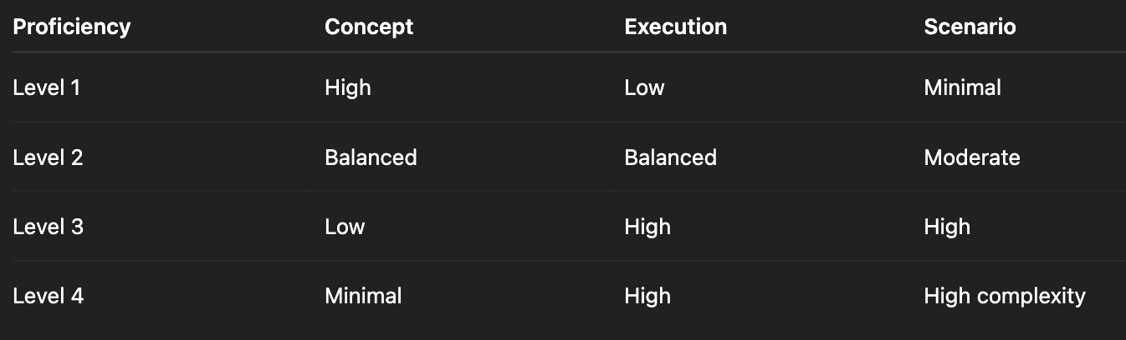

Proficiency | Concept % | Execution % | Scenario %
Level 1 | 70 | 20 | 10
Level 2 | 40 | 40 | 20
Level 3 | 20 | 50 | 30
Level 4 | 10 | 60 | 30

Prompt includes distribution explicitly.

8 Accuracy Safeguards
Every content prompt must include:
- “Use only provided documents.”
- “Cite reference sections.”
- “Do not assume missing policy.”
- “State if not available.”
Additionally:
- Context must be pre-filtered by FG / PWO / SWO.
- Chunking must be semantic, not fixed-length.
- Metadata filtering before similarity search.

9️ Advanced Optimization Layer
After sufficient data:
Prompts may include performance signals:
Example:
“Control Point CP-17 shows rising minor deviations.
Generate preventive microlearning focused on threshold vigilance.”
This makes content predictive, not reactive.

10 What Makes This Different from Standard AI Course Generation
Standard AI:
Prompt → Course.
Our model:
Capability Framework → Locked LOs → Blueprint → RAG → Structured Prompt → Validation → Intervention Tagging → Impact Measurement.
It is engineered, not creative.

11. ️Database Schema Requirements
You need tables for:
Capability Instances
instance_id
fg_id
pwo_id
swo_id
capability_id
proficiency_level
Company Documents
doc_id
company_id
tags
embedding_vector
confidentiality_level
Templates
template_id
template_type
structure_json
prompt_instructions
Generated Content
content_id
instance_id
role_id
template_id
version
ai_model_used
approval_status

12. Governance & Approval Layer (VERY Important)
- Learning Objectives are version-controlled.
- Content versions stored with trigger metadata.
- Intervention record stores baseline risk.
- Regeneration happens only when the LO version changes.
How To Improve Content Accuracy

🔹 1. Strong Retrieval (RAG Quality)
Bad RAG → hallucination
Good RAG → policy-grounded output
Improvements:
- Chunk by semantic sections (not fixed length)
- Tag documents by FG/PWO/SWO
- Use metadata filtering before similarity search
- Retrieve 5–10 relevant chunks, not 1

🔹 2. Structured Prompting
Never use:
“Generate training module”
Use:
Use only the provided documents.
If information is missing, state “Not available in repository.”
Cite document section reference.
Do not invent process steps.
Force model constraints.

🔹 3. Output Schema Validation
After AI output:
- Validate required sections
- Check references exist
- Run hallucination detection (compare statements vs retrieved docs)

🔹 4. SME Approval Workflow
Best model:
- AI Draft
- SME edits
- Version locked
- Feedback loop stored
This improves future generation.

🔹 5. Continuous Learning Loop
Track:
- Learner performance
- Question difficulty
- Drop-off points
- Feedback ratings
Use that data to refine prompts.
Companies must be able to:
- Review AI-generated content
- Edit before publishing
- Lock approved versions
- Regenerate content
- Track revisions
You must include:
- Content workflow:
  - Draft
  - Review
  - Approved
  - Archived
Otherwise legal teams will block adoption.

13. ️Personalization Layer (Advanced)
Once system matures:
- Track learner assessment scores
- Detect weak capability areas
- Auto-trigger:
  - Microlearning
  - Refresher
  - Simulation
This converts system from static LMS → Adaptive Capability Engine.

14. ️Security Considerations
Since companies upload internal documents:
You must implement:
- Tenant isolation
- Encrypted storage
- Role-based access
- Prompt injection protection
- No cross-company data mixing
- Audit logs

15. ️Recommended Tech Stack
Backend:
- Node.js / Python
- Vector DB (Weaviate)
- PostgreSQL
- Redis (for generation queue)
AI:
- RAG architecture
- Controlled prompting
- Output schema validation
Frontend:
- Angular (you’re already strong here)
- Dynamic rendering engine for simulations
- JSON-driven module UI

16. ️Phased Implementation Strategy
Don’t build everything at once.
Phase 1 (MVP)
- Refresher modules
- Scenario based Assessment generation
- Manual review workflow
Phase 2
- Microlearning auto-trigger
- Simulation branching engine
Phase 3
- Adaptive personalization
- Capability gap analytics dashboard

17.️ What Makes This Powerful
Dynamic course generation must be:
Constraint-driven
Hierarchy-grounded
Control-point anchored
Contextualized via RAG
Validated post-generation
Governed via versioning
Linked to risk triggers
Only then does it become:
Operationally credible
Predictively useful
Audit-safe
Benchmark-ready

If done right, your system becomes:
- Capability-driven
- Company-specific
- Role-specific
- Proficiency-aligned
- AI-assisted but human-governed
We must need to:
- Tie content to capability instances
- Use strict templates
- Force citation from repository
- Require SME approval
- Track learning effectiveness
Our system will outperform manual content in:
- Speed
- Scale
- Personalization
- Cost
And match it in:
- Accuracy
- Credibility
This is far beyond an LMS.
It becomes:
Enterprise Capability Intelligence Platform
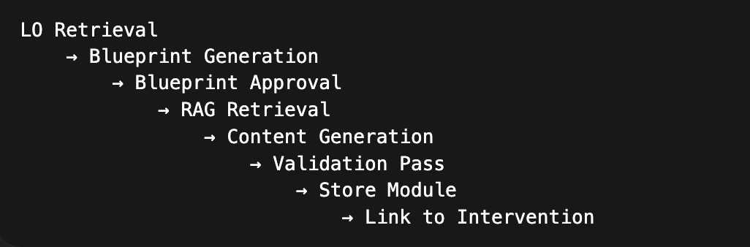

MASTER SYSTEM PROMPT (Global Guardrail)
This should be injected as the system message in every generation.

1. SYSTEM PROMPT
You are an enterprise instructional design engine.

You generate structured operational learning content grounded strictly in the provided capability framework and company context.

You must:
- Use only the provided context documents.
- If information is not available in the context, explicitly state: "Not available in repository."
- Never invent policy, thresholds, or process steps.
- Anchor explanations to the provided Skill, Task, and Control Point.
- Align content strictly to the given Learning Objectives.
- Maintain role-specific relevance.
- Follow the requested output schema exactly.
- Do not include generic theory unless explicitly required.
- Cite document section references when relevant.

Your output must be precise, structured, and operationally grounded.

2️ BLUEPRINT GENERATION TEMPLATE
Used before full content generation.
🔹 USER PROMPT – Blueprint Stage
Generate a structured instructional blueprint.

INPUT:

Capability Instance:
- Industry: {industry}
- Functional Group: {fg}
- PWO: {pwo}
- SWO: {swo}
- Capability: {capability}
- Proficiency Level: {proficiency}

Learning Objectives (Pre-Approved):
{lo_list}

Skill:
{name + description}

Task:
{name + description}

Control Points:
{cp_list}

Content Type:
{Microlearning / Refresher / Simulation / Assessment}

Block Distribution:
- Concept: {x}%
- Execution: {y}%
- Scenario: {z}%

Constraints:
- Target Duration: {duration}
- Target Role: {role}

OUTPUT FORMAT:
1. Module Title
2. Module Duration
3. Block Breakdown (ordered list)
- Block Name
- Block Purpose
- Linked LO
- Linked Skill/Task/Control Point
4. Assessment Plan (if applicable)

Do not generate narrative content yet.

3️ FULL CONTENT GENERATION TEMPLATE
This is used after blueprint approval.
🔹 USER PROMPT – Content Generation
Generate structured learning content.

INPUT:

Capability Instance Metadata:
{full hierarchy}

Learning Objectives (Locked):
{lo_list}

Instructional Blueprint:
{approved_blueprint}

Skill:
{name + description}

Task:
{name + description}

Control Points:
{cp_list with thresholds}

Role Context:
{role_description}

Company Context Documents:
{retrieved_context_packet}

Performance Signal Context (if predictive trigger):
- Risk Score: {value}
- Trend: {increasing/stable}
- Incident Type: {if any}

CONSTRAINTS:
- Use only provided company context.
- Cite policy references where relevant.
- If any required information is missing, state: "Not available in repository."
- Do not invent thresholds or procedures.
- Align strictly to Learning Objectives.
- Maintain operational tone.
- Avoid generic theory unless explicitly required.

OUTPUT FORMAT:

1. Module Title
2. Learning Objectives Covered
3. Structured Content by Block
- Block Heading
- Content
- Control Point Emphasis (if applicable)
4. Scenario (if applicable)
5. Assessment Questions
- Question
- Options (if MCQ)
- Correct Answer
- Rationale
- Policy Reference
6. Key Reinforcement Summary

4️ MICRO-LEARNING TEMPLATE (Highly Constrained)
🔹 USER PROMPT – Microlearning
Generate a microlearning module.

Constraints:
- Duration: 5–7 minutes
- Cover only 1 Skill
- Cover max 2 Control Points
- Max 3 assessment questions
- Avoid deep theory
- Focus on practical execution

INPUT:
{Skill}
{Task}
{Control Points}
{LO}
{Context Packet}

OUTPUT FORMAT:
1. Title
2. Why This Matters (Risk Context)
3. Execution Steps
4. Critical Control Point Alerts
5. 3 Assessment Questions
6. Key Takeaways

5️ SCENARIO SIMULATION TEMPLATE
🔹 USER PROMPT – Simulation
Generate a scenario-based simulation.

INPUT:
- Role: {role}
- Skill: {skill}
- Task Sequence: {ordered tasks}
- Control Points: {cp_list}
- Context Packet: {documents}
- Trigger Context (if predictive): {risk_signal}

INSTRUCTIONS:
- Create a realistic workplace scenario.
- Use actual company terminology.
- Introduce a triggering situation.
- Create branching decision points at each Control Point.
- Show consequence for incorrect choices.
- Provide corrective explanation.
- Cite relevant policy sections.

OUTPUT FORMAT:
1. Scenario Setup
2. Decision Point 1
- Options
- Correct Path
- Incorrect Path + Consequence
3. Decision Point 2
4. Final Outcome
5. Learning Reinforcement Summary

6️ ASSESSMENT GENERATION TEMPLATE
🔹 USER PROMPT – Assessment Only
Generate structured assessment questions.

INPUT:
Learning Objectives:
{lo_list}

Skill:
{skill}

Control Points:
{cp_list}

Context:
{retrieved_documents}

INSTRUCTIONS:
For each Learning Objective generate:
- 1 Knowledge Question
- 1 Application Question
- 1 Scenario-Based Question

Each question must include:
- Correct Answer
- Rationale
- Policy Reference

Do not generate questions outside provided context.

7️ VALIDATION PROMPT (SECOND PASS AI QA)
Run after content generation.
🔹 USER PROMPT – Validation
Evaluate the generated module.

CHECK:
1. Are all Learning Objectives covered?
2. Is any content unsupported by the context packet?
3. Are Control Points accurately referenced?
4. Are assessment questions aligned with LOs?
5. Is any policy invented?

OUTPUT:
- Alignment Status: PASS / FAIL
- List of Issues
- Required Corrections

8️ PREDICTIVE REINFORCEMENT TEMPLATE
Used when triggered by rising risk.
🔹 USER PROMPT – Predictive Context
Generate preventive reinforcement content.

Risk Context:
- Control Point: {cp}
- Current Risk Score: {value}
- Trend: {increasing}
- Incident Frequency: {count}

Focus:
- Prevent escalation
- Reinforce threshold vigilance
- Highlight early warning signs

Use only provided documents.

9️ IMPLEMENTATION NOTES FOR ENGINEERING
Must enforce:
- Structured JSON output option
- Deterministic formatting
- Temperature ≤ 0.4 for compliance content
- Token limit guards
- Strict schema validation before persistence
- Version tagging for each generated module
- Intervention ID linkage

10 FINAL ENGINEERING STRUCTURE
Pipeline must look like:


